 Translated from Chinese (Simplified) to English - www.onlinedoctranslator.com

IRS42
Integrated 485 bus open-loop stepper driver

User Manual V1.0.6

Shenzhen Gerui IoT Technology Co., Ltd.

Table of contents
one,Product Introduction - 1 -
1.1 Product Overview - 1 -
1.2 Product Features - 1 -
1.3 Application Areas - 1 -
two,Mechanical, electrical and environmental specifications - 2 -
2.1 Mechanical Installation Drawing - 2 -
2.2 Installation Notes - 2 -
2.3 Electrical specifications - 3 -
2.4 Operating environment and parameters - 3 -
three,Driver interface and wiring description - 3 -
3.1 General Description of Product Interface - 3 -
3.2 DIP switch - 4 -
3.2.1 Driver address setting - 4 -
3.2.2 Communication baud rate setting - 5 -
3.2.3 Terminal resistance setting - 5 -
3.2.4 Current setting - 5 -
3.3 Indicator Lights - 6 -
3.4 RS485 communication interface - 6 -
3.5 Input Signal Interface - 7 -
3.5.1 Input signal description and wiring diagram - 7 -
3.5.2 Input signal interface function - 9 -
3.5.3 Input Signal Interface Function Description - 10 -
3.6 Output signal interface - 11 -
3.6.1 Output signal description and wiring diagram - 11 -
3.6.2 Output signal interface function - 11 -
3.6.3 Output signal interface function description - 12 -
3.6.4 Brake Motor Brake Wiring Diagram - 12 -
3.7 Motor Control Output Interface - 13 -
3.8 Power Input Interface - 13 -
Four,MODBUS communication protocol and functions - 14 -
4.1 Basic communication parameters - 14 -
4.2 MODBUS register address definition - 15 -
4.2.1 Status parameter group (read-only) - 15 -
4.2.2 Public parameter group (read and write) - 18 -
4.2.3 Common parameters in open loop mode (read and write) - 20 -
4.2.4 Common parameter group in closed loop mode (read and write) - twenty one -
4.2.5 Driver basic control parameter group 1 (read and write) - twenty two -
4.2.6 Return to origin parameter group (read and write) - twenty four -
4.2.7 Driver Basic Control Parameter Group 2 (Read and Write) - 25 -
4.2.8 Public Parameter Group 2 (Read and Write) - 26 -
4.2.9 Input and output function parameter group (read and write) - 27 -
4.2.10 Multi-segment mode parameter group (read and write) - 29 -
4.2.11 Performance parameter group (read and write) - 33 -
4.2.12 Brake Control Parameter Group (Read and Write) - 36 -
4.2.13 Status and fault code parameter group (read only) - 37 -
4.2.14 User parameter group (read and write) - 40 -
4.3 Common MODBUS function codes - 41 -
4.3.1 Read Holding Register Command 0x03 - 41 -
4.3.2 Write Single Register Command 0x06 - 41 -
4.3.3 Write multiple registers command 0x10 - 42 -
4.4 Communication Error Codes - 42 -
4.4.1 CRC Check Error - 42 -
4.4.2 Function code sending error - 43 -
4.4.3 Reading illegal data address error - 43 -
4.4.4 The address of written data exceeds the address range - 43 -
4.4.5 Read register count overflow - 44 -
4.4.6 Illegal read and write data error of function code - 44 -
4.4.7 Data written into register exceeds limit - 44 -
4.5 Application Examples - 45 -
4.5.1 Position Mode Operation Setting Example - 45 -
4.5.2 Speed ​​Mode Operation Setting Example - 46 -
five,Motion Control Function Introduction - 48 -
5.1 Position Mode - 48 -
5.2 Speed ​​Mode - 49 -
5.3 Return to origin mode - 50 -
5.3.1 Mode 17 (Negative Limit Return to Zero) - 50 -
5.3.2 Mode 18 (Positive limit return to zero) - 51 -
5.3.3 Mode 19 (Home Return 1) - 51 -
5.3.4 Mode 20 (Home Return 2) - 52 -
5.3.5 Method 21 (Home Return 3) - 52 -
5.3.6 Method 22 (Home Return 4) - 52 -
5.3.7 Mode 23 (origin + positive limit return to zero 1) - 53 -
5.3.8 Mode 24 (origin + positive limit return 2) - 54 -
5.3.9 Mode 25 (origin + positive limit return to zero 3) - 54 -
5.3.10 Mode 26 (origin + positive limit return to zero 4) - 55 -
5.3.11 Mode 27 (origin + negative limit return to zero 1) - 56 -
5.3.12 Mode 28 (origin + negative limit return to zero 2) - 57 -
5.3.13 Mode 29 (origin + negative limit return to zero 3) - 57 -
5.3.14 Mode 30 (origin + negative limit return to zero 4) - 58 -
5.3.15 Mode 33 (Z signal return to zero 1) - 58 -
5.3.16 Mode 34 (Z signal return to zero 2) - 58 -
5.3.17 Methods 35 and 37 (Current Position as Origin) - 59 -
5.3.18 Mode 38 (Position return to zero mode 1) - 59 -
5.3.19 Mode 39 (Position return to zero mode 2) - 59 -
5.4 Multi-segment mode - 60 -
5.4.1 Multi-position mode - 60 -
5.4.1.1 IO Trigger + Path IO Mode - 60 -
5.4.1.2 IO trigger single cycle mode - 62 -
5.4.1.3 IO trigger continuous loop mode - 62 -
5.4.2 Multi-speed mode - 63 -
5.5 Motion Control Instructions - 65 -
5.5.1 Startup Command - 65 -
5.5.2 Stop Command - 65 -
six,Alarm indication - 66 -
6.1 Alarm fault codes - 66 -
6.2 Indicator light flashes - 68 -
seven,Warranty and after-sales - 69 -
7.1 Warranty - 69 -
7.1.1 Free warranty - 69 -
7.1.2 Warranty Exclusion - 69 -
7.2 Exchange - 69 -
7.2.1 Product Replacement for Faulty Products - 69 -
7.2.2 Exchange for non-product failure - 70 -
7.3 Returns - 70 -
7.4 After-sales Service - 70 -
eight,Version Revision History - 71 -

Product Introduction

1.1 Product Overview
IRS42 integrated 485 bus open-loop stepper driveryesShenzhenGerui IoT Technology Co., Ltd.'s latest digital hybrid stepper servo driver with serial port debugging function integrates the MODBUS-RTU standard protocol specification. The power supply, IO input and output ports, and communication interface use PH2.0-10P pin headers. Users can set various parameters such as subdivision, current, speed, and operating mode through the host computer debugging software, greatly enriching the product's practical functions and meeting the application needs of most occasions.
IRS42 integrated 485 bus open-loop stepper driverThis servo-like control principle combines the advantages of both open-loop stepper and servo systems. The latest 32-bit DSP control technology significantly enhances stepper system performance. It offers excellent stability and ultra-low noise at both medium and low speeds, while significantly improving high-speed torque, expanding the speed range of stepper motors. Smooth, precise pure sinusoidal current vector control effectively reduces motor heating, and its high compatibility and cost-effectiveness make it suitable for most applications.

1.2 Product Features
●New generation 32-bit DSP technology, good stability, strong compatibility and high cost performance
●onlySupport open-loop moderun
●Support speed mode, position mode, multi-position mode(reserve)And return to origin mode
● Current, lock current, subdivision, PI and other parameters can be set and queried through the master station
●Use RS485 bus with isolation and support standard MODBUS-RTU protocol
●DIP switch SW1-4 sets the driver communication address, which can support 15devices, more can be set through the main station
●14-way optoelectronically isolated programmable input interface, receiving external control signals to realize drive enable, start/stop, limit and other functions
●1 optoelectronically isolated programmable output interface, outputting driver status and control signals, such as alarm, arrival, return to origin completion, etc.
●Built-in micro-segmentation, excellent low-speed stability
●With overcurrent(reserve), overvoltage, undervoltage, phase loss, etc.Call the policeProtection function
●Pure sinusoidal current vector control effectively reduces motor heating
●DC power supply, inputVoltage range:DC12V~40V

1.3 Application Areas
Suitable for various small and medium-sized automation equipment and instruments, such as engraving machines, marking machines, cutting machines, plotters, CNC machine tools, automatic assembly equipment, etc. It works particularly well in equipment applications where users expect low noise and high speed.

Mechanical, electrical and environmental specifications

2.1 Mechanical Installation Drawing
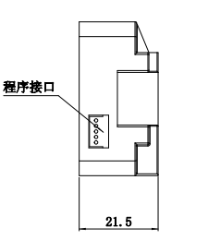
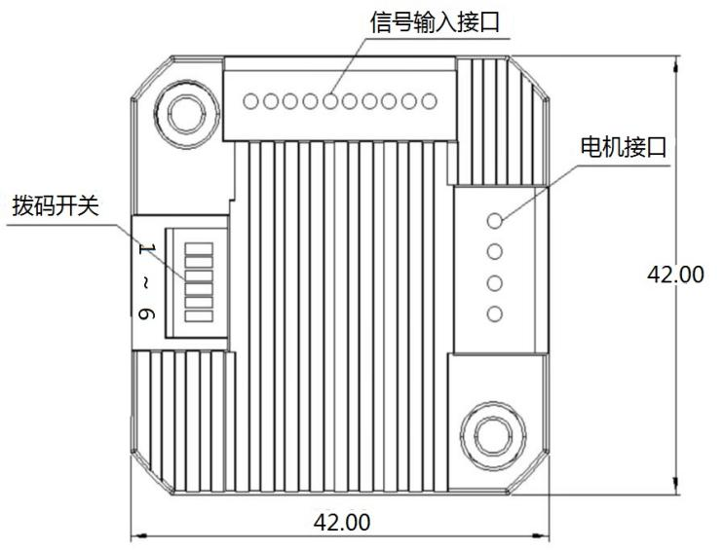
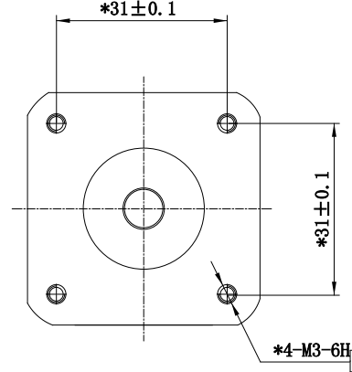

Figure 1 Installation dimensions (unit: mm)

2.2 Installation Notes
- InstallIntegrated stepper driver,Do not knock on the rear cover of the motor to avoid affecting the running performance.When designing the installation dimensions, considerwiringterminalofSize and wiring.
- In order to ensure good heat dissipation conditions, a larger installation interval must be reserved as much as possible during actual installation.,If multiple integrated drives are installed side by side, you can installFan,All-in-oneDrivesurfaceForming strong air convection to assist drivingDeviceHeat dissipation ensures that the driver operates within a reliable operating temperature range.

2.3 Electrical specifications
illustrate | IRS42 integrated 485 bus typeOpen loopSteppingDrive
illustrate | Minimum | Typical values | Maximum | unit
Output current | 0 | - | 2000 | mA
Input power voltage | 12 | twenty four | 40 | VDC
Control signal input current | 7 | 10 | 16 | mA
Insulation resistance | 50 | - | - | MΩ

2.4 Operating environment and parameters
Cooling method |  | Natural cooling, fan cooling
Usage Environment | occasion | Do not place it near other heating equipment. Avoid dust, oil mist, corrosive gas, high humidity and strong vibration. Flammable gas and conductive dust are prohibited.
Usage Environment | temperature | -25℃~55℃
Usage Environment | humidity | 40~90%RH
Usage Environment | vibration | 10~55Hz/0.15mm
Storage temperature |  | -25℃~65℃

Driver interface and wiring description

3.1 ProductsInterface Overview
IRS42Integrated 485 bus typeOpen loopThe power supply, IO input and output ports, and communication interface of the stepper driver use a PH2.0-10P straight pin socket, which has a total of 10 pins, as shown in Figure 3.1 below.
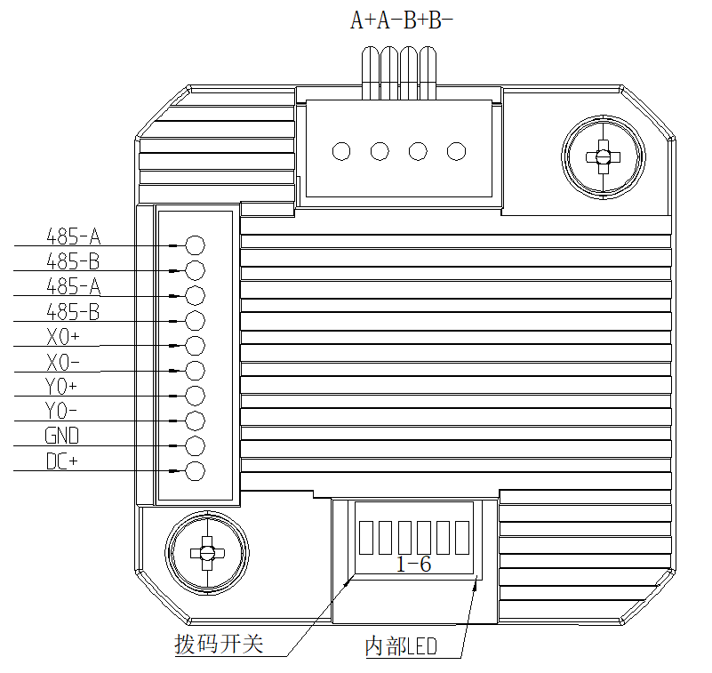

Figure 3.1 IRS42 interface diagram

The function description of each pin is shown in Table 3.1 below.
Table 3.1interfaceFunctionoveralldescribe
Pins | name | illustrate
1 | DC+ | Positive pole of power supply, range: DC12~40V
2 | GND | Negative pole of power supply
3 | Y0- | Opto-isolated programmable output interface (maximum drive current 50mA)
4 | Y0+
5 | X0- | DC 5V~24VPower supply, connected to the negative terminal of the external input signal, supports differential input
6 | X0+ | DC 5V~24VPower supply, connected to the positive terminal of the external input signal, supports differential input
7 | 485-B | 485 communication interface B end
8 | 485-A | 485 communication interface A terminal
9 | 485-B | 485 communication interface B end
10 | 485-A | 485 communication interface A terminal

3.2 DIP switch
Table 3.2DIP switch function description
name | Function | illustrate
Dip switch SW1-SW6 | Set address, baud rate, terminal resistance selection | SW1-SW4: Drive address setting
Dip switch SW1-SW6 | Set address, baud rate, terminal resistance selection | SW5: Baud rate setting
Dip switch SW1-SW6 | Set address, baud rate, terminal resistance selection | SW6:120ΩTermination resistance effective bit

3.2.1 Driver address setting
The host computer uses RS485 bus communication, and the dial switch can control up to15485 driver, the driver communication address is through SW1-SW4Dial setting,Off represents 0, on represents 1, and each dial corresponds to a hexadecimal data.The address range is1-15, as shown in Table 3.3When the drive address is set to be greater than15When the host computer sends a command to change the address, it is necessary to set the address. However, before setting, SW1-SW4All dial settings areoffStatus, setup completedand saveback,A power cycle is required to take effect.
Note: Make sure the communication address of each driver is unique, otherwise it will cause communication conflicts!
Table 3.3Drive address setting
SW1 | SW2 | SW3 | SW4 | =address(ID)
on=1 off=0  ×  1 | on=1 off=0  ×  2 | on=1 off=0  ×  4 | on=1 off=0  ×  8 | =address(ID)
off | off | off | off | 1(CanCustom)
on | off | off | off | 1
off | on | off | off | 2
on | on | off | off | 3
off | off | on | off | 4
on | off | on | off | 5
off | on | on | off | 6
on | on | on | off | 7
off | off | off | on | 8
on | off | off | on | 9
off | on | off | on | 10
on | on | off | on | 11
off | off | on | on | 12
on | off | on | on | 13
off | on | on | on | 14
on | on | on | on | 15

3.2.2 Communication baud rate setting
Communication baud rate can be set by SW5Settings are as shown in Table 3 below.4If the communication baud rate in the table cannot meet the use requirements, you can customize the communication baud rate through the host computer, provided that the SW5Dial tooffStatus, see register 0x0015 for detailsofdescribe.
Table 3.4Communication baud rate setting
SW5 | Baud rate
off | 9600 (customizable)
on | 115200

3.2.3Terminal resistance setting
Users can dial SW6Whether to incorporate a 120Ω terminal resistor into the communication terminal depends on the application scenario, as shown in Table 3.5shown.
Table 3.5120Ω terminal resistor selection
SW6 | 120Ω terminal resistor
off | invalid
on | efficient

3.2.4 Current setting
IRS42 integrated 485 bus open loop stepperDriver, default current in open loop mode,As shown in the following table3.6shown.It cannot set the current by dialing the code.If the userthinkAdjust the current size by yourself, you can use the host computer softwareset up.
surface3.6Open loop default current size
Current setting (A) | Open loop
Current setting (A) | Peak | RMS
default | 1.4 | 1.0

3.3 Indicator Lights
IRS42 integrated 485 bus open loop stepperDrive indicator lightIt is a retractable SMD LED, and its basic functions are shown in Table 3.7 below.
Table 3.7Indicator lamp definition
name | Function | illustrate
Green LED | Power supply, save parameter function indicator, restore factory settings function indicator, dial status switch indicator,  Alarm indicator light | When the power is on normally, the green light is always on and the red light is off. When saving parameters, restoring factory settings, switching the dial status, or when the device is abnormal, the red and green lights will flash alternately to alarm. The flashing pattern is shown in Chapter 6.
Red LED

3.4 RS485 communication interface
IRS42 integrated 485 bus open loop stepperThe communication interface of the driver adopts PH2.0-10P straight pin socket, as shown in Figure 3.2 below.
The interface has a total of 10 pins, corresponding to pins 1 to 10 from bottom to top, of which pins7, 8, 9, 10For RS485 half-duplex communication,Pins 7 and 8 are a group, connected to the B and A ends of the 485 communication. Pins 9 and 10 are a group, which are cascaded with pins 7 and 8 inside the driver and can be used to connect to the next driver device.In actual use, it is recommended to use a chain method to connect this interface one level at a time. The pin definitions are shown in Table 3.8 below.

Figure 3.2IRS42 integrated 485 bus open-loop stepper driverInterface Diagram
Table 3.8 PH2.0-10P pin function distribution
Pins | definition
DC+ | Positive terminal of power supply
GND | Power supply GND terminal
X0+、X0- | Input IO port
Y0+、Y0- | Output IO port
485-B | RS485 communication portBend
485-A | RS485 communication portAend

3.5 Input Signal Interface

3.5.1 Input signal description and wiring diagram
IRS42 integrated 485 bus open loop stepperThe drive provides1st RoadInput programmable interface with optical isolation.
Input interface can be externally connected5V~24VTo ensure reliable conduction of the optocoupler inside the driver, the drive current on the controller side must be at least 10mA, and the input level pulse width must be greater than 10ms, otherwise the driver may not respond normally.
After the driver is powered on normally, the effective level of the input interface is initially defaulted to the rising edge or high level.The user can also configure the effective level of the input interface to be initially set to falling edge or low level by default through the master station.
Taking the X0 input port as an example, the following figure is a wiring diagram of the input signal interface:
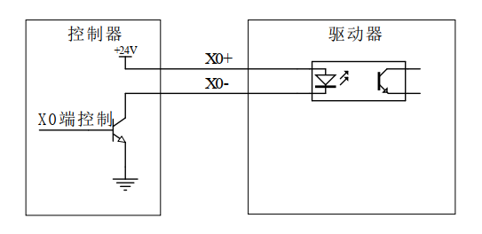

Figure 3.3 Input signal wiring diagram
Notice:IRS42 integrated 485 bus open loop stepperDriveThe default input interface supports DC 5V~24V signals and does not require external resistors.

If the input terminal is connected to a sensor, thenSupport NPNType and PNP type sensorswiringTaking the X0 input port as an example, the wiring diagram is shown in the following two figures:
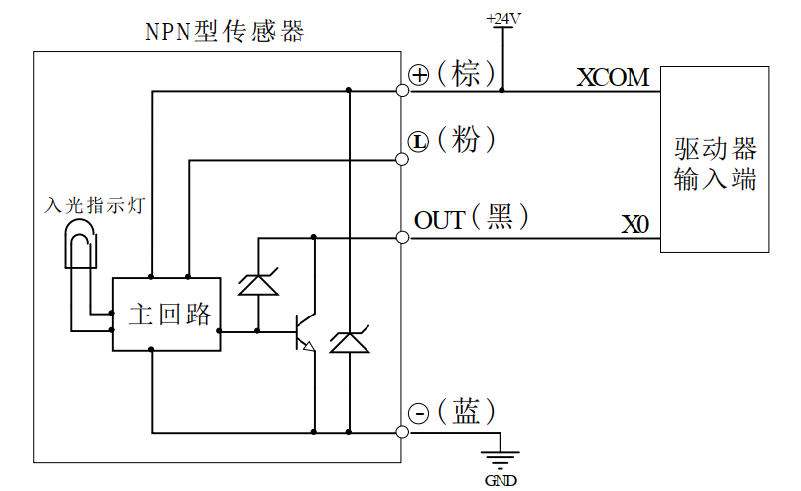
Figure 3.4 NPN sensorWiring Diagram
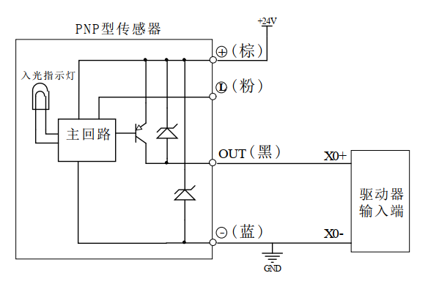
Figure 3.5 PNP type sensorWiring Diagram

3.5.2 Input signal interface function
IRS42 integrated 485 bus open loop stepperThe driver has a variety of configurable input ports. Users can set the corresponding input IO port functions through the host computer.Each input IO port can be setThere are as many as 21 functions, as shown in Table 3.9 below.
Table 3.9Input interface function definition
name |  | illustrate | Functional Description
Input signal interface | X0+ | DC5V~24V power supply,  Support differential signal input | 0: undefined;  1: Origin signal;  2: Positive limit signal;  3: Negative limit signal;  4: Motor MF enable/release signal;  5: Brake control input signal;  6: Alarm clear signal;  7: Function code restores factory settings signal;  8: Normal stop signal;  9: Emergency stop signal;  10: Trigger position mode motion (relative and absolute position modes are selected via register 0x0036);  11: Trigger speed mode motion;  12: JOG+point motion;  13: JOG-point movement;  14: Return to origin enable signal (used in conjunction with the return to origin mode register);  15: PTIN0;  16:PTIN1;  17:PTIN2;  18:PTIN3;  19: PTIN4 (reserved);  20: Multi-position mode start signal;  21: Clear the in-place output signal;  Note: In the above function selection: Signals 4, 5, 12, 13, and 15-20 are valid at high level or low level, and the others are valid at rising edge or falling edge;
Input signal interface | X0- | DC5V~24V power supply,  Support differential signal input

3.5.3 Input Signal Interface Function Description
The input signal interface function description is as follows3.10As shown:
Table 3.10Input interface function description
Function | describe
1: Origin signal | Connect the origin sensor;
2: Positive limit signal | Connect to the positive limit sensor;
3: Negative limit signal | Connect to the negative limit sensor;
4: Motor enable/release signal | Enable signal to put the motor into lock or release state;
5: Brake control input signal | Control the brake motor's brake or release;
6: Alarm clear signal | EEPROM read and write error, communication error recovery;  Overvoltage and undervoltage automatic recovery;
7: Parameters restored to factory settings signal | Parameters are restored to factory settings;
8: Normal stop signal | The motor decelerates and stops;
9: Emergency stop signal | The motor not only over-decelerates but also stops directly;
10: Trigger position mode motion | Set the motion according to registers 0x0030~0x0036;
11: Trigger speed mode motion | Set the motion according to registers 0x0030~0x0036;
12: JOG+point motion | Set the movement according to register 0x0046~0x0049;
13: JOG-point movement | Set the movement according to register 0x0046~0x0049;
14: Return to origin enable signal | Trigger the return to origin function;
15:PTIN0 | Multi-segment mode path number setting;
16:PTIN1 | Multi-segment mode path number setting;
17:PTIN2 | Multi-segment mode path number setting;
18:PTIN3 | Multi-segment mode path number setting;
19: PTIN4 (reserved) | Multi-segment mode path number setting;
20: Multi-stage mode start signal | Start multi-stage mode motion;
21: Clear in-position output signal | If the output port in-position signal function is turned on, this function can be used to clear the in-position output signal;

3.6 Output signal interface

3.6.1 Output signal description and wiring diagram
IRS42 integrated 485 bus typeopenThe ring stepper driver provides a 1-channel output with a programmable interface with optical isolation.
After the driver is powered on normally, the effective state of the output interface is initially defaulted to normally open output.The user can also configure the effective state of the output interface through the master station to initially default to normally closed output.
The following figure is a wiring diagram of the output signal interface:
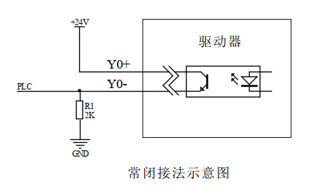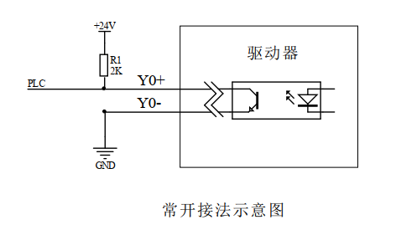
Figure 3.6 Schematic diagram of output interface normally closed connection Figure 3.7 Schematic diagram of output interface normally open connection

3.6.2 Output signal interface function
IRS42 integrated 485 bus typeopenThe output port of the stepper driver has a variety of configurable functions. The user can set the corresponding output IO port function through the host computer. Each output IO port can be set with up to 11 functions, as shown in Table 3.11 below.
Table 3.11 Input/output interface function definition
name |  | illustrate | Functional Description
Output | Y0+ | Low-speed digital signal  Output interface | 0: undefined;  1: Alarm output signal (0: normal 1: alarm);  2: In-position output signal (0: not in position 1: in position);  3:Axis lock status signal (0: release 1: lock);  4: motion status signal (0: stationary 1: moving);  5: Return to origin completion signal (0: not completed 1: completed);  6: Conduction of origin signal;  7: Conducting positive limit signal;  8: Conduct negative limit signal;  9: Brake control signal (0: brake 1: release);  10: Z signal output;  11:Brake control PWM adaptive output signal (reserved);
Output | Y0- | Low-speed digital signal  Output interface

3.6.3 Output signal interface function description
The output signal interface function description is shown in Table 3.12 below:
Table 3.12 Output interface function description
Function | describe
1: Alarm output signal | When the driver is in alarm state, the signal output is valid;
2: Output signal when in position | When the planned trajectory is completed in position mode, the signal output is valid;
3: Lock axis status signal | When the motor is in the locked shaft state, the signal output is valid;
4: Motion status signal | When the motor is in running state, the signal output is valid;  Note:The valid level state will be maintained for at least 20ms so that the master station can detect it;
5: Return to origin completion signal | After returning to the origin, the signal output is valid;
6: Conducting origin signal | When the origin is reached, the signal output is valid;
7: Conducting positive limit signal | When the positive limit position is reached, the signal output is valid;
8: Conducting negative limit signal | When the negative limit position is reached, the signal output is valid;
9: Brake control signal | When the external brake control signal is input or the upper computer sets the brake control signal, the output of this bit is valid;
10: Z signal output | Output encoder Z signal status;
11:Brake control PWM adaptive output signal (reserved); | For drivers with dedicated brake output circuits, the brake can be directly connected to the brake output port for control by configuring this output function;

3.6.4 Brake Motor Brake Wiring Diagram
IRS42 integrated 485 bus typeopenThe outputs of the stepper driver include control functions for the brake motor. Users simply set one of the output functions in the 'Output Port Function Selection' register to 'Brake Control Signal' on the host computer. Then, by configuring the registers in the 'Brake Control Parameter Group', they can control the brake motor.
The following figure is a schematic diagram of the wiring of the brake motor brake (Table 3.13 is a description of the relevant parameters in the diagram):
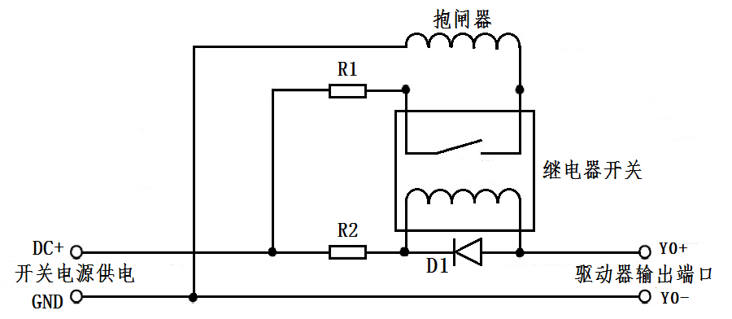
Figure 3.8 Brake motor brake wiring diagram

Table 3.13 Brake motor brake connection diagram parameter description
name | Logo | illustrate
Switching power supply | DC+ | Connect to +24 or +5V power supply
Switching power supply | GND | Ground terminal
Driver output port | Y0+ | The common end of the single-ended output port is compatible with common cathode and common anode
Driver output port | Y0- | One of the output ports needs to be configured as the 'brake control signal' function
protective resistor | R1 | If the brake is powered by DC24V, R1 can be smaller or not connected; if the brake is powered by DC5V, R1 should be larger.
protective resistor | R2 | R2 can be connected to a 1~2K resistor to limit the current to prevent damage to the optocoupler components inside the driver;  Please refer to the relay specification to determine whether it is necessary to connect;
Freewheeling diode | D1 | Protect the internal components of the driver from being damaged by induced voltage. Please refer to the relay specification to determine whether it is necessary to connect;
brake |  | The control mechanism of the brake motor is usually in the release state after the power is turned on, and the motor can run freely. Before use, you must confirm its power supply voltage to avoid excessive voltage and burn out the brake device;

3.7Motor control output interface
name |  | color | illustrate | Function
Motor | A+ | red | Motor interface | Two-phase stepper motor wiring port, pay attention to the line sequence  The wiring has been correctly connected at the factory. If it is not necessary, please do not change the wiring sequence at will.
Motor | A- | blue | Motor interface
Motor | B+ | green | Motor interface
Motor | B- | black | Motor interface

3.8Power input interface
name |  | illustrate | Function
VDC | DC+ | Power interface | Power input  DC12V~40V
VDC | GND | Power interface | Power input  DC12V~40V

MODBUS communication protocol and functions

4.1 Basic communication parameters
Table 4.1 Basic communication parameters
name | describe | Remark
Hardware Interface | RS485 | No RS232 support
Communication Type | Asynchronous half-duplex | Communication between master and slave devices
Baud rate | 9600 (default) | Can be set by dialing or host computer
Communication Protocol | MODBUS-RTU | -
Function code | 0x03: Read single or multiple data  0x06: Write single data  0x10: Write multiple data | -
Data character composition | Start bit: 1 bit Data bits: 8 bits  Parity bit: None (default) / Odd / Even Stop bit: 1 bit (default) / 2 bits | Communication data format
Verification method | CRC16 | Low position in front, high position in the back
Number of devices | 15(default) | Higher configurable

485 bus single message communication rate:
Baud rate | Time from start of receiving to completion of sending T1 (ms)
115200 | 3.49
38400 | 6.30
19200 | 10.46
9600 | 20.32
When multiple axes send messages continuously, there will be a PLC processing waiting time T2 between messages. This value varies depending on the master station and baud rate.

4.2 MODBUS register address definition

4.2.1 Status parameter group (read-only)
Table 4.2 Status parameter group register
Register address | project | illustrate | Setting range  Note: Other values ​​are invalid | default value
Status parameter group (read-only)
0x0000 | Driver version | Driver version; | (read-only) | -
0x0001 | Drive label | The label of the same series of products is used to distinguish general products from customized products; | (read-only) | -
0x0002 | Drive node number | MODBUS current communication slave node number; | (read-only) | -
0x0003 | Driver operating mode | The corresponding bit is 1 to indicate the current working mode;  0x01: Speed ​​mode trigger;  0x02: Relative position mode trigger;  0x04: Absolute position mode trigger;  0x08: Trigger the return to origin mode;  0x1P: Multi-segmentLocationmodel, P is the corresponding path segment, and the P value range is 0-15;  0x2P: Multi-segmentspeedmodel, P is the corresponding path segment, and the P value range is 0-15;  0x40: JOG+ motion;  0x80: JOG-motion;  The remaining values:invalid; | (read-only) | -
0x0004 | Drivestate | Bit0: release/enable status;  0: release;  1: Enable;  Bit1: stationary/moving status;  0: Still;  1: Exercise;  Bit2-Bit3: return to zero state;  0: invalid;  1: Returning to the origin;  2: Return to origin completed;  Bit4-Bit5: motor movement direction;  0: invalid, stop state;  1: Positive direction;  2: Reverse direction;  Bit6: Alarm status;  0: normal;  1: Alarm;  Bit7~Bit15: reserved; | (read-only) | -
0x0005 | currentGiven theoretical speed | currentReal-time givenTheoryrunSpeed ​​value;  Unit: rev/min  This variable can be used to view the theoretical running trajectory of the motor; | (read-only) | -
0x0006 | Current actual running speed | The current actual running speed value;  Unit: rev/min | (read-only) | -
0x0007 | Current error code | 0: normal;  Other values: Error code (seeSection 4.2.13);  Note: It is recommended to query registers 0x019A, 0x019C~0x019D to obtain alarm information; | (read-only) | -
0x0008 | Current error subcode | The error subcode corresponding to the current error code;  0: normal;  Other values:mistakeSubcode(SeeSection 4.2.13);  Note: It is recommended to query registers 0x019A, 0x019C~0x019D to obtain alarm information; | (read-only) | -
0x0009 | Inputmouth  Status flag | Indicates whether the level of the corresponding input port is valid or invalid;  Bit0:X0endmouthInput status;  Bit1~Bit15: reserved;  0: The input level of this portRecognized asinvalid;  1: The input level of this portRecognized asefficient; | (read-only) | -
0x000A | Output Port  Status flag | Indicates that the state of the corresponding output port is normally open or normally closed output;  Bit0: Y0 port output status;  Bit1~Bit15: Reserved;  0: The port output is normally open;  1: The port output is normally closed; | (read-only) | -
0x000B | Current position low16-bit | Calculated based on the position after returning to the origin or the initial position after power-on as the zero pointCurrent Location(The highest sign bit represents both positive and negative directions); | (read-only) | -
0x000C | Current position high16-bit |  | (read-only) | -
0x000D | currentactualCurrent | In open-loop and closed-loop modes, the currentIn running stateofactualEffective current value;  Unit: mA | (read-only) | -
0x000E | Current phase A current | Real-time display of phase A current;  Unit: mA | (read-only) | -
0x000F | Current B phase current | Real-time display of phase B current;  Unit: mA | (read-only) | -
0x0010 | Closed loop current given current | In closed-loop mode, the currentRun the givenEffective current value;  Unit: mA | (read-only) | -
0x0011 | DIP status | Bit0: SW1 input status;  Bit1: SW2 input status;  Bit2: SW3 input status;  Bit3: SW4 input status;  Bit4: SW5 input status;  Bit5~Bit15: reserved;  0: Input level is invalid;  1: Input level is valid; | (read-only) | -
0x0012 | PT segment path number | Lower 8 bits: path execution completion status (hold), used for query when the current path execution is completed;  High 8 bits: If in running state, it indicates the path segment currently being executed; if in static state, it indicates the path segment that was completed last time; | (read-only) | -
0x0013 | reserve;

4.2.2 Public parameter group (read and write)
Table 4.3 Common parameter group registers
Register address | project | illustrate | Setting range  Note: Other values ​​are invalid | default value
Common parameter group
0x0014 | Driver Node Settings | When SW1-SW4Status isoffOnly when you have the drive node number set by yourself;  1-15：SW1-SW4Dial setting;  16-65535: When the setting range of the DIP switch is insufficient, a new node can be set through this register;  Note:After modification, save and re-power on to take effect; | 0-65535  (Read and Write) | 1
0x0015 | Custom communication baud  Rate | When SW5The dial status isoffWhenCyclingSet the communication baud rate;  0:9600  1:14400  2:19200  3:38400  4:115200  5:128000  6:256000  Note:After modification, save and re-power on to take effect; | 0~6  (Read and Write) | 0
0x0016 | Serial port data format | 0: 8-bit data, no parity, 1 stop bit;  1: 8-bit data, no parity, 2 stop bits;  2: 8-bit data, even parity, 1 stop bit;  3: 8-bit data, odd parity, 1 stop bit;  Note:After modification, save and re-power on to take effect; | 0~3  (Read and Write) | 0
0x0017 | Save parameter function | The corresponding bit position is 1, and the corresponding parameter group can be saved; the specific corresponding relationship is as follows:  Bit0: Synchronous update function (0x0001). It is generally not recommended to enable this function.  0: NosynchronousrenewEEPROM;  1: Synchronous updateEEPROM;  Bit1: Reserved;  Bit2: Save common parameter group 1 (0x0004);  Bit3: Save open-loop common parameter group (0x0008);  Bit4: Save the closed-loop common parameter group (0x0010);  Bit5: Save basic control parameter group 1 (0x0020);  Bit6: Save the back-to-origin parameter group (0x0040);  Bit7: Save basic control parameter group 2 (0x0080);  Bit8: Save common parameter group 2 (0x0100);  Bit9: Save multi-segment mode parameter group (0x0200);  Bit10: Save performance parameter group (0x0400);  Bit11: Save brake parameter group (0x0800);  Bit12: Save status, fault code parameter group (0x1000);  Bit13: Save input and output parameter group (0x2000);  Bit14: Save user parameter group (0x4000);  Bit15: Save all parameters function (0x8000);  0: do not save;  1: Save all 'read and write' attribute parameters;  When using Bit1~Bit15 to save parameters, the red and green lights flash twice each alternately. When saving is completed, the green light remains on and the red light goes out. You can also query this bit through the master station. If it is 0, it means that the parameters are saved successfully. | 0~65535  (Read and Write) | 0
0x0018 | Overrun parkingFunction | Corresponding to Bit position 1, select the corresponding overtravel parking function;  Bit0:Free parking/Emergency StopMode selection bit;  0: Free stop (decelerate and stop when overtravel);  1: Emergency stop (immediate stop when overtravel);  Bit1: Positive and negative hard limit overtravel prohibition function bit;  0: Disabled;  1: Disable (default)  Bit2: Positive and negative soft limit overtravel prohibition function bit;  0: Disabled;  1: Disable (default) | 0~7  (Read and Write) | 6
0x0019 | Alarm clear | 0: invalid;  1: Alarm cleared; | 0~1  (Read and Write) | 0
0x001A | Parameters restored to factory settings  Place | 0: invalid;  1: Restore factory settings; | 0~1  (Read and Write) | 0
0x001B | Storage function  Enablecontrol | The corresponding bit position is 1, which turns on the corresponding storage function;  Bit0: Phase memory enable function;  0: disabled;  1: Enable;  Bit1: Function of storing current position when power is off;  0: disabled;  1: Enable; | 0～3  (Read and Write) | 0
0x001C | Open-loop and closed-loop mode switching/  Initial rotation direction switch | IRS42 integrated 485 bus open loopstepper drive,Only open loop mode is supported, butCanSelf-set via host computerInitial rotation direction;  Bit0:Open-loop and closed-loop modesSwitch;  0: open loop mode (fixed to open loop mode);  1: Closed-loop mode;  Bit1: Initial rotation direction switch;  0: factory default rotation direction;  1: The rotation direction is opposite to the factory default;  Note:After modification, save and re-power on to take effect; | 0~3  (Read and Write) | 0
0x001D | Return to origin timeout alarm  set up | In homing mode, timeout alarm time setting;  Unit: s | 0~4000  (Read and Write) | 1000

4.2.3 Common parameters in open loop mode (read and write)
Table 4.4 Common parameter group registers in open loop mode
Register address | project | illustrate | Setting range  Note: Other values ​​are invalid | default value
Common parameter groups in open-loop mode
0x001E | Open loop current setting | The effective current value in open-loop mode can be adjusted arbitrarily;  Unit: mA | 0~6000  (Read and Write) | 1000
0x001F | Open loop subdivision setting | Arbitrarily set the subdivision value in open-loop mode;  Unit: Pul/rev | 200~60000  (Read and Write) | 10000
0x0020 | Open loop soft start time | Unit: ms | 1～65535  (Read and Write) | 200
0x0021 | Open loop lock machine current time | The time required for the open loop to go from running to locking state;  Unit: ms | 1～1000  (Read and Write) | 200
0x0022 | Open loop lock current ratio | Set the lock current percentage in open loop mode;  unit:% | 0~100  (Read and Write) | 50
0x0023 | Open-loop algorithm selection | 0: A algorithm;  1: B algorithm(Reserved);  Note:After modification, save and re-power on to take effect; | 0~1  (Read and Write) | 0

4.2.4 Common parameter group in closed loop mode (read and write)
Table 4.5 Common parameter group registers in closed-loop mode
Register address | project | illustrate | Setting range  Note: Other values ​​are invalid | default value
Common parameter groups in closed-loop mode
0x0024~  0x002F | Closed-loop mode dedicated register (reserved);

4.2.5 Basic control parameter group of the driver1(Read and Write)
Table 4.6 Driver basic control parameter group register
Register address | project | illustrate | Setting range  Note: Other values ​​are invalid | default value
Driver basic control parameter group1(Open and closed loopShared)
0x0030 | Starting speed | Set the starting speed of the motor;  Unit: rev/min | 1-3000  (Read and Write) | 5
0x0031 | Acceleration time | Acceleration time;  Unit: ms | 0~2000  (Read and Write) | 100
0x0032 | Deceleration time | deceleration time;  Unit: ms | 0~2000  (Read and Write) | 100
0x0033 | Maximum speed | Set the maximum speed of the motor;  Unit: rev/min  Note: In speed mode, the direction of the motor is determined by the positive or negative value of the set value;For the setting rules of negative values, please refer to the introduction of register '0x0034~0x0035 total pulse number'; | -3000~3000  (Read and Write) | 60
0x0034 | Total pulse count low16Bit | In position mode, motorThe total number of pulses running, including the total number of steps in the three stages of acceleration, constant speed, and deceleration;The highest bit represents the sign bit. A positive number represents the number of pulses running in the positive direction, and a negative number represents the number of pulses running in the reverse direction.  Note:likeSet 100000(Original code:0x0001 86A0) pulses, then highGiven value0x0001, low bitGiven value0x86A0;  For example, if -100000 (original code: 0x8001 86A0) pulses are set, since negative numbers are stored in the form of two's complement, the high-order given value is 0xFFFE and the low-order given value is 0x7960.  The given pulse number in the reverse direction can be calculated using the following formula:  2^32-abs (number of pulses given in the reverse direction) | -2147483648~  2147483648  (Read and Write) | 5000
0x0035 | Total pulse count high16Bit |  | -2147483648~  2147483648  (Read and Write) | 5000
0x0036 | Relative position/absolute position  Placechoose | When the external IO signal is selected to trigger the position mode, this bitSetting upefficient;  0: relative position: take the current static point as the starting point;  1: Absolute position: The starting point is the position after power-on or homing. | 0~1  (Read and Write) | 0
0x0037 | Startup Command | The corresponding bit position 1 can trigger the corresponding working mode;  0x01: Speed ​​mode trigger;  0x02: Relative position mode trigger;  0x04: Absolute position mode trigger;  0x08: Trigger the return to origin mode;  0x1P: Multi-segment(position/speed)modelTrigger start, P is the corresponding path segment, the P value range is 0-15, the specific trigger start is position or speed operation, which is related to the path function register 1;  0x40: JOG+ motion;  0x80: JOG-motion;  The remaining values:reserve; | 0~255  (Read and Write) | 0
0x0038 | Stop Command | 0: normal stop;  1: Emergency stop;  2: Run at the set speed or along the planned trajectory until it stops; | 0~2  (Read and Write) | 2
0x0039 | Motor enable//release  Order | The motor enable/release function can be controlled by instructions or external IO input signals.  The following are the functions of the corresponding bits of this register:  Bit0: soft enable bit;  0: release;  1: Enable;  Bit1: Initial power-on, motor self-enable control bit;  0: After power-on, the motor is in the released state and you need to set Bit 0 to 1 to enable the motor lock.  1: After power-on, the motor is in the locked state, but it can be released by setting Bit 0 to 0;  Note: If a certain input port function is configured as4(Motor MF enable/release signal), the IO port enable/release motor function is valid only when Bit0 of this register is 0; | 0~3  (Read and Write) | 0
0x003A | Clear current location | In absolute position mode, clear the current position value;  0: invalid;  1: current position is cleared to 0; | 0~1  (Read and Write) | 0

4.2.6 Return to origin parameter group (read and write)
Table 4.7 Return to origin parameter group register
Register address | project | illustrate | Setting range  Note: Other values ​​are invalid | default value
Return to origin parameter group (Open and closed loopShared)
0x003B | Return to origin mode | Currently, the return to zero mode can be set to 17-30, 33-35, 37-39, (-3)-(-6);  Note: The highest bit represents the sign bit;  For details on the return method, please refer to section '5.3 Return to Origin Mode'; | 0~65535  (Read and Write) | 0
0x003C | Return to origin speedV1 | In the homing mode, the speed of high-speed detection of the origin;  Unit: rev/min  Note: The starting speed of high-speed origin detection is '0x003D Home Speed ​​V2'; | 1~3000  (Read and Write) | 30
0x003D | Return to origin speedV2 | In homing mode, the speed of low-speed detection of origin or compensation value;  Unit: rev/min  Note: The starting speed of low-speed detection origin or compensation value is 0; | 1~300  (Read and Write) | 10
0x003E | Return to origin acceleration time | Acceleration time during the return to origin process;  Unit: ms | 0 ~2000  (Read and Write) | 100
0x003F | Return to origin deceleration time | Deceleration time during homing;  Unit: ms | 0 ~2000  (Read and Write) | 100
0x0040 | Origin low position compensation value | Position compensation value after returning to origin;  The highest bit represents the sign bit,Positive values ​​represent positive compensation values, and negative values ​​represent negative compensation values.;  Note:likeSet 100000(Original code:0x0001 86A0) pulses, then highGiven value0x0001, low bitGiven value0x86A0;  For example, if -100000 (original code: 0x8001 86A0) pulses are set, since negative numbers are stored in the form of two's complement, the high-order given value is 0xFFFE and the low-order given value is 0x7960.  The given pulse number in the reverse direction can be calculated using the following formula:  2^32-abs (number of pulses given in the reverse direction) | -2147483648~  2147483648  (Read and Write) | 0
0x0041 | Origin high position compensation value |  | -2147483648~  2147483648  (Read and Write) | 0
0x0042 | Stalled-rotor return to zero torque retention time | Unit: ms | 0-65535  (Read and Write) | 100
0x0043 | Return to zero current percentage | unit:% | 1~300 | 100
0x0044 | Open and closed loop position return to zero  Lower 16 bits of position value | In open-loop and closed-loop position return mode, the maximum operating position value set is unsigned; | 0~4294967295  (Read and Write) | 5000
0x0045 | Open and closed loop position return to zero  Position value high 16 bits |  | 0~4294967295  (Read and Write) | 5000

4.2.7 Basic drive controlParameter Group2(Read and Write)
Table 4.8 Basic drive controlParameter Group2register
Register address | project | illustrate | Setting range  Note: Other values ​​are invalid | default value
Basic drive controlParameter Group2(Open and closed loop shared)
0x0046 | JOG motion starting speed | Unsigned  Unit: rev/min | 1~3000  (Read and Write) | 2
0x0047 | JOG motion acceleration speed | Unit: ms | 0~2000  (Read and Write) | 2
0x0048 | JOG motion deceleration speed | Unit: ms | 0~2000  (Read and Write) | 2
0x0049 | JOG movement maximum speed | Unsigned;  Unit: rev/min | 0~3000  (Read and Write) | 30
0x004A~  0x0055 | reserve;

4.2.8 publicParameter Group2(Read and Write)
Table 4.9 publicParameter Group2register
Register address | project | illustrate | Setting range  Note: Other values ​​are invalid | default value
publicParameter Group2(Open and closed loop shared)
0x0056 | Positive overtravel maximum position low 16 bits | Unsigned;  Unit: Pul | 0~2147483647  (Read and Write) | 2147483647
0x0057 | Positive overtravel maximum position high 16 bits | Unsigned;  Unit: Pul | 0~2147483647  (Read and Write) | 2147483647
0x0058 | Low 16 bits of the maximum position of reverse overtravel | Unsigned;  Unit: Pul | 0~2147483647  (Read and Write) | 2147483647
0x0059 | Reverse overtravel maximum position high 16 bits | Unsigned;  Unit: Pul | 0~2147483647  (Read and Write) | 2147483647
0x005A | Automatically return to zero point after power on  Enable | If this function is turned on, the drive will automatically enable after power-on and perform the zero point return action. However, please note that the zero point return method parameter values ​​must be set and saved in advance so that the zero point return action can be performed normally after power-on.  0: The automatic return to zero point function at power on is disabled;  1: Enable the automatic return to zero point function upon power on; | 0~1  (Read and Write) | 0
0x005B~  0x005D | reserve;

4.2.9enterOutputFunction parameter group (read and write)
Table 4.10enterOutputFunction parameter group register
Register address | project | illustrate | Setting range  Note: Other values ​​are invalid | default value
Input and output function parameter group (shared for open and closed loop)
0x01B0 | Input Port  Effective level | Bit0: input port X0 control bit;  Bit1~Bit15: reserved;  0: rising edge or high level is valid;  1: Falling edge or low level is valid; | 0~65535  (Read and Write) | 0
0x01B1 | Input port X0  Function selection | 0: undefined;  1: Origin signal;  2: Positive limit signal;  3: Negative limit signal;  4: Motor MF enable/release signal (when the value of register 0x0039 is 1~3, this input control function is invalid);  5: Brake control input signal;  6: Alarm clear signal;  7: Parameters are restored to factory settings;  8: Normal stop signal;  9: Emergency stop signal;  10: Trigger position mode motion (relative and absolute position modes are selected via register 0x0036);  11: Trigger speed mode motion;  12: JOG+point motion;  13: JOG-point movement;  14: Return to origin enable signal (used in conjunction with the return to origin mode register);  15: PTIN0;  16:PTIN1;  17:PTIN2;  18:PTIN3;  19: Reserved;  20: Multi-stage mode start signal (TRIG);  21: Clear the in-place output signal;  Note: In the above function selection: Signals 4, 5, 12, 13, and 15-20 are valid at high level or low level, and the others are valid at rising edge or falling edge; | 0~21  (Read and Write) | 1
0x01B2~  0x01BB | reserve
0x01BC | Input port X0  Filter time | Set the filter time of input port X0-X1, with a minimum resolution of 1000us;  Unit: us | 0~65535  (Read and Write) | 1000
0x01BD~  0x01C6 | reserve
0x01C7 | Output Port  Valid status | Bit0: output port Y0 control bit;  Bit1~Bit15: Reserved;  0: After power on, the default is normally open output;  1: After power on, the default is normally closed output; | 0~65535  (Read and Write) | 0
0x01C8 | Output port Y0  Function selection | 0: undefined;  1: Alarm output signal;  2: Output signal when in position;  3:Axis lock status signal (0: release 1: lock);  4: motion status signal (0: stationary 1: moving);  5: Return to origin completion signal;  6: Conduction origin signal status;  7: Conduction positive limit signal status;  8: Conduction negative limit signal status;  9: Brake control signal;  10: Z signal output (reserved);  11:Brake control PWM adaptive output signal; | 0~11  (Read and Write) | 5
0x01C9~  0x01CC | reserve
0x01CD | Disable in-position output in different modes | Bit0: speed mode; Bit1: relative position;  Bit2: absolute position; Bit3: return to zero;  Bit4: multi-stage position; Bit5: multi-stage speed;  Bit6: JOG+ motion; Bit7: JOG- motion;  0: Disabled;  1: prohibition is effective;  Note: The corresponding bit is disabled in multi-segment mode, which is only valid when powered on. The subsequent status is determined by function register 1. | 0~65535  (Read and Write) | 0
0x01CE~  0x01CF | reserve;

4.2.10Multi-segment mode parameter group (read and write)
Table 4.11Multi-segment mode parameter group register
Register address | project | illustrate | Setting range  Note: Other values ​​are invalid | default value
Multi-position mode parameter group (shared for open and closed loop)
0x005E | Multi-stage mode start signal enable control | 0: Multi-stage mode does not require a start signal (path 0 is invalid in this case);  1: Multi-stage mode requires a start signal (path 0 can be started in this case); | 0-1  (Read and Write) | 1
0x005F | Multi-segment mode IO combination  Filter time | Set the multi-segment IO combination logic filter time, with a minimum resolution of 1000us;  Unit: us | 0~65535  (Read and Write) | 1000
0x0060 | Path 0 function setting 1 | In multi-segment mode, path 0 function setting 1:  The corresponding bit setting can select the corresponding function;  Bit0: Position/speed mode selection bit;  0: Position mode;  1: Speed ​​mode;  Bit1: relative/absolute position mode selection bit;  0: relative position;  1: absolute position;  Bit2: IO in place output signal disabled;  0: Disabled;  1: prohibition is effective;  Bit3: Jump function enable bit;  0: jump is disabled;  1: Enable jump;  Bit4~Bit7: jump path selection bit;  Setting value range: 0-15;  Bit8~Bit15: Reserved;  Note: In multi-speed mode, the jump function is not supported; | 0~65535  (Read and Write) | 0
0x0061 | Path 0 function setting 2 | In multi-segment mode, path 0 function setting 2:  The corresponding bit setting can select the corresponding function;  Bit0: homing enable bit;  0: prohibit the path from returning to the origin;  1: Enable the path to return to the origin;  Bit1: whether to execute the path after returning to the original state;  0: prohibit execution of this path;  1: Enable execution of this path;  Bit2: selection of return to origin parameters;  0: Select the speed, acceleration/deceleration time, and return compensation value parameters of 0x003C-0x0041;  1: Select the speed, acceleration/deceleration time, and return compensation value parameters for this path segment;  Bit3-Bit7: Reserved;  Bit8~Bit15: Return to origin mode selection bits; for details on the return to origin mode, see section '5.3 Return to origin mode'; | 0~65535  (Read and Write) | 0
0x0062 | Path 0 position segment  Total pulse count low | In multi-segment position mode, it is used to set the total number of pulses for the path segment, including the total number of steps in the three stages of acceleration, constant speed, and deceleration;  The highest bit represents the sign bit. A positive number represents the number of pulses running in the positive direction, and a negative number represents the number of pulses running in the reverse direction.  Note: If 100000 (original code: 0x0001 86A0) pulses are set, the high-order given value is 0x0001 and the low-order given value is 0x86A0;  For example, if -100000 (original code: 0x8001 86A0) pulses are set, since negative numbers are stored in the form of two's complement, the high-order given value is 0xFFFE and the low-order given value is 0x7960.  The given pulse number in the reverse direction can be calculated using the following formula:  2^32-abs (number of pulses given in the reverse direction) | -2147483648~  2147483648  (Read and Write) | 0
0x0063 | Path 0 position segment  Total pulse count high |  | -2147483648~  2147483648  (Read and Write) | 0
0x0064 | Path 0 run/return to origin  Maximum speed | (1) In the multi-position/speed mode, set the maximum speed of the motor within the corresponding path;  (2) If the path segment has the homing function enabled and Bit 2 of the register 'Path Function Setting 2' is set to 1, then the 'Homing Speed ​​V1' uses the value of this register;  Unit: rev/min  Note: (1) In the multi-speed mode, the direction of the motor is determined by the positive or negative value of the set value; the setting rules for negative values ​​can refer to the introduction of register '0x0034~0x0035 total pulse number';  (2) The multi-position mode and the return to zero speed settings must be positive values; | -3000~3000  (Read and Write) | 60
0x0065 | Path 0 run/return to origin  Starting speed | - In multi-position/speed mode, set the starting speed of the motor within the corresponding path;  (2) If the path segment has the homing function enabled and Bit 2 of the register 'Path Function Setting 2' is set to 1, then the 'Homing Speed ​​V2' uses this value;  Unit: rev/min | 1~3000  (Read and Write) | 5
0x0066 | Path 0 run/return to origin  Acceleration time | - In multi-position/speed mode, set the acceleration time within the corresponding path;  - If the path segment has the homing function enabled and Bit 2 of the register 'Path Function Setting 2' is set to 1, the 'Homing Acceleration Time' uses the value of this register;  Unit: ms | 0~2000  (Read and Write) | 100
0x0067 | Path 0 run/return to origin  Deceleration time | - In multi-position/speed mode, set the deceleration time within the corresponding path;  - If the homing function is enabled for this path segment and Bit 2 of the register 'Path Function Setting 2' is set to 1, the 'Home Deceleration Time' uses the value of this register;  Unit: ms | 0~2000  (Read and Write) | 100
0x0068 | Path 0 is executed  Waiting time | In multi-segment loop mode, the waiting time after the current path segment is executed and before the next path segment is executed;  Unit: ms | 0~65535  (Read and Write) | 0
0x0069 | Path 0 back to origin  Low compensation value | In multi-segment mode, the position compensation value after the current path returns to the origin;  The highest bit represents the sign bit, a positive value represents a positive compensation value, and a negative value represents a negative compensation value;  Note: If 100000 (original code: 0x0001 86A0) pulses are set, the high-order given value is 0x0001 and the low-order given value is 0x86A0;  For example, if -100000 (original code: 0x8001 86A0) pulses are set, since negative numbers are stored in the form of two's complement, the high-order given value is 0xFFFE and the low-order given value is 0x7960.  The given pulse number in the reverse direction can be calculated using the following formula:  2^32-abs (number of pulses given in the reverse direction) | -2147483648~  2147483648  (Read and Write) | 0
0x006A | Path 0 back to origin  High compensation value |  | -2147483648~  2147483648  (Read and Write) | 0
0x006B | After path 0 returns to the origin  Waiting time | In multi-segment mode, after path 0 returns to the origin, the waiting time before the execution of the path segment is completed;  Unit: ms | 0~65535  (Read and Write) | 0
0x0070~  0x007B | Comparing the function of path 0, path 1 related setting registers occupy 12 registers
0x0080~  0x008B | Comparing the function of path 0, path 2 related setting registers occupy 12 registers (reserved)
0x0090~  0x009B | Comparing the function of path 0, path 3 related setting registers occupy 12 registers (reserved)
0x00A0~  0x00AB | Comparing the function of path 0, path 4 related setting registers occupy 12 registers (reserved)
0x00B0~  0x00BB | Comparing the function of path 0, the related setting registers of path 5 occupy 12 registers (reserved)
0x00C0~  0x00CB | Comparing the function of path 0, the related setting registers of path 6 occupy 12 registers (reserved)
0x00D0~  0x00DB | Comparing the function of path 0, path 7 related setting registers occupy 12 registers (reserved)
0x00E0~  0x00EB | Comparing the function of path 0, the related setting registers of path 8 occupy 12 registers (reserved)
0x00F0~  0x00FB | Comparing the function of path 0, the related setting registers of path 9 occupy 12 registers (reserved)
0x0100~  0x010B | Compare to the function of path 0, the related setting registers of path 10 occupy 12 registers (reserved)
0x0110~  0x011B | Comparing the function of path 0, the related setting registers of path 11 occupy 12 registers (reserved)
0x0120~  0x012B | Compare to the function of path 0, the related setting registers of path 12 occupy 12 registers (reserved)
0x0130~  0x013B | Comparing the function of path 0, the related setting registers of path 13 occupy 12 registers (reserved)
0x0140~  0x014B | Comparing the function of path 0, the related setting registers of path 14 occupy 12 registers (reserved)
0x0150~  0x015B | Comparing the function of path 0, the related setting registers of path 15 occupy 12 registers (reserved)
Note: The unused registers in the range of 0x0060~0x015F are reserved registers of each path and have no function at present.

4.2.11Performance parameter group (read and write)
Table 4.8Performance parameter group register
Register address | project | illustrate | Setting range  Note: Other values ​​are invalid | default value
Performance parameter group
0x0160 | Phase loss detectionThreshold | Set the threshold value for the phase loss detection function;  Note:After modification, you need to save and re-power on to take effect; | 0~100  (Read and Write) | -
0x0161 | closed loopCurrent setting  Control factor adjustment | closed loopCurrent given control factor adjustment percentage;  unit:% | 0~500  (Read and Write) | 100
0x0162 | intermediate frequencyEnable shock handling | 0: oscillation processing is disabled;  1: Oscillation processing is enabled; | 0~1  (Read and Write) | 1
0x0163 | Medium frequency oscillation  inhibitionCoefficient K | intermediate frequencyoscillationinhibitionCoefficient K adjustment percentage;  unit:% | 0~500  (Read and Write) | 100
0x0164 | Medium frequency oscillation  StartspeedV1 | set upMedium frequency oscillation startsspeedV1;  Unit: rev/min | 1~2000  (Read and Write) | -
0x0165 | Medium frequency oscillation  maximumspeedV2 | set upThe medium frequency oscillation is the largestspeedV2;  Unit: rev/min | 1~2000  (Read and Write) | -
0x0166 | Motor winding resistance adjustment | Motor winding resistance adjustment percentage;  unit:% | 0~500  (Read and Write) | 100
0x0167 | Open current loop  Parameter adjustment enable | 0: PI parameter adjustment is disabled  1: PI parameter adjustment enabled | 0～1  (Read and Write) | 0
0x0168 | Open current loop  Proportional gain | Open loop current loop proportional gain adjustment percentage;  unit:% | 0~500  (Read and Write) | 100
0x0169 | Open current loop  Integral gain | Open-loop current loop integral gain adjustment percentage;  unit:% | 0~500  (Read and Write) | 100
0x016A | Open ring shaft  Proportional gain | Open loop axis proportional gain adjustment percentage;  unit:% | 0~500  (Read and Write) | 100
0x016B | Open ring shaft  Integral gain | Open-loop axis integral gain adjustment percentage;  unit:% | 0~500  (Read and Write) | 100
0x016C | Open-loop proportional gain  Adaptive adjustment enabled | 0: Proportional gain adaptive adjustment is disabled  1: Proportional gain adaptive adjustment enabled | 0～1  (Read and Write) | 0
0x016D | Open-loop proportional gain  AdaptiveStarting ratio | Open-loop proportional gain adaptationInitial ratio adjustment per thousand;  For example, if the setting value is 625, the corresponding open-loop proportional gain adaptive starting ratio is 0.625 times; | 1~1000  (Read and Write) | 800
0x016E | Open-loop proportional gain  AdaptiveStartspeedV1 | Open-loop proportional gain adaptationStartspeedV1;  Unit: rev/min | 1~2000  (Read and Write) | 60
0x016F | Open-loop proportional gain  AdaptiveTurning PointspeedV2 | Open-loop proportional gain adaptationTurning PointspeedV2;  Unit: rev/min | 1~2000  (Read and Write) | 900
0x0170 | Open-loop proportional gain  Adaptive Limiting | Open loop proportional gain adaptive limit percentage;  unit:% | 100~500  (Read and Write) | 150
0x0171 | Open-loop current  Adaptive adjustment enabled | 0: Current adaptive regulation is disabled  1: Current adaptive regulation enabled | 0～1  (Read and Write) | 0
0x0172 | Open-loop current  Adaptiveadjust  StartspeedV1 | Open-loop current adaptationAdjustment startspeedV1;  Unit: rev/min | 1~2000  (Read and Write) | -
0x0173 | Open-loop current  Adaptiveadjust  maximumspeedV2 | Open-loop current adaptationAdjustment maximumspeedV2;  Unit: rev/min | 1~2000  (Read and Write) | -
0x0174 | Open-loop current  Adaptiveadjust  Maximum limit | Open-loop current adaptationadjustMaximum limit adjustment percentage;  unit:% | 100~200  (Read and Write) | 120
0x0175 | Open and closed loop power-up current  percentageadjust | unit:% | 0~500  (Read and Write) | 100
0x0176 | reserve;
0x0177~  0x0186 | Closed-loop mode dedicated register (reserved);
0x0187 | Open and closed loop alarm detection  Enable | Open and closed loop alarm detection enable control:  0: Disable the corresponding alarm function;  1: Enable the corresponding alarm function;  The following are the control functions of the corresponding bits:  Bit0: Overcurrent alarm (reserved);  Bit1: Over-voltage or under-voltage alarm;  Bit2~Bit3: Reserved;  Bit4: Phase loss alarm;  Bit5: Reserved;  Bit6: Return to origin timeout alarm;  Bit7: out-of-tolerance alarm;  Bit8~Bit15: Reserved; | 0~65535  (Read and Write) | 255
0x0188~  0x018D | Closed-loop mode dedicated register (reserved);
0x018E | Phase storage time | Phase memory storage time;  Unit: ms | 500~65535 | 1000
0x018F | Mechanical transmission ratio | For stepper motors with reducers;  Mechanical transmission ratio = reduction gear / motor gear;  High 8 bits: represents the reduction gear;  Lower 8 bits: represents the motor gear;  Please note that if the mechanical transmission ratio is not 1, the parameters of the position and speed related registers will correspond to the position and speed after the reducer output.  Note: After modification, save the parameters and re-power on to take effect; | 0x0101~0x3232 | 0x0101

4.2.12Brake control parameter group (read and write)
Table 4.13Brake control parameter group register
Register address | project | illustrate | Setting range  Note: Other values ​​are invalid | default value
Brake control parameter group
0x0190 | Brake engagement delay | Brake engagement (brake holding) delay time;  Unit: ms | 0~65535  (Read and Write) | 0
0x0191 | Brake release delay | Brake release (release) delay time;  Unit: ms | 0~65535  (Read and Write) | 0
0x0192 | Brake control selection | 0: The brake is controlled by the master (used in conjunction with register 0x0193 - master control brake enable);  1: The driver controls the brakes automatically (the driver can enable/release the brakes);  2: The brake is controlled by external IO input signal (used in conjunction with input and output function registers); | 0~2  (Read and Write) | 0
0x0193 | Master control brake enable | 0: Brake (motor locked);  1: Release the brake (motor is free); | 0~1  (Read and Write) | 0

4.2.13 state,Fault code parameter group (read only)
Table 4.14 state,Fault code parameter group register
Register address | project | illustrate | Setting range  Note: Other values ​​are invalid | default value
state,Fault code parameter group (Open and closed loopShared)
0x0194 | The most recent fault code | Err0x01: Overcurrent;(reserve)  SubErr: 0x10;  Err0x02: Passowepressure;  SubErr: 0x20: Overvoltage alarm;  0x21: Undervoltage alarm;  Err0x03:Overtravel alarm;  SubErr: 0x30: Positive hard limit overtravel;  0x31: Reverse hard limit overtravel;  0x32: Forward soft limit overtravel;  0x33: Reverse soft limit overtravel;  Err0x04: EEPROM read/write error;  SubErr: 0x41: read error;  0x42: write error;  Err0x05: Communication error;  SubErr: 0x51: CRC check error;  0x52:Function codemistake;  0x53:Reading illegal dataWrong address;  0x54:Writing dataaddressOut of range;  0x55: ReadregisterNumber overflow (up to 16 at a time)register);  0x56: Function code illegal read and write error;  0x57:In registerWriteData limit exceeded;  Err0x06: Phase loss alarm;  SubErr:0x60: Both A and B phases are missing alarm;  0x61: Phase A is missing;  0x62: Phase B is missing;  Err0x07: Out-of-tolerance alarm;(reserve)  SubErr: 0x70: normal deviation alarm;  0x71: Out-of-tolerance alarm caused by overvoltage;  0x72:Depend onoweOut-of-tolerance alarm caused by pressure;  Err0x08:Return to originovertakehourCall the police;  SubErr: 0x80;  Err0x09:Restore factory settings/save parameters;  SubErr: 0x90:Restore factory settings;  0x91:reserve;  0x92: Save common parameter group 1;  0x93: Save the common open-loop parameter group;  0x94: Save the closed-loop common parameter group;  0x95: Save basic control parameter group 1;  0x96: Save the back-to-origin parameter group;  0x97: Save basic control parameter group 2;  0x98: Save common parameter group 2;  0x99: Save multi-segment mode parameter group;  0x9A: Save performance parameter group;  0x9B: Save the brake parameter group;  0x9C: Save fault code parameter group;  0x9D: Save input and output parameter group;  0x9E: Save user parameter group;  0x9F: Save all parameter groups;  Err0x0A:Alarm when speed parameter setting is unreasonable;  SubErr: 0xA0:Vmax>Vmin; | (read-only) | -
0x0195 | The most recent fault code  Subcode |  | (read-only) | -
0x0196 | The most recent two fault codes |  | (read-only) | -
0x0197 | The most recent two fault codes  Subcode |  | (read-only) | -
0x0198 | The last three fault codes |  | (read-only) | -
0x0199 | The last three fault codes  Subcode |  | (read-only) | -
0x019A | Communication fault information | Bit0:EEPROMRead Error;  Bit1:EEPROMWrite Error;  Bit2:CRC check error;  Bit3:Function codemistake;  Bit4:Reading illegal dataWrong address;  Bit5:Writing dataaddressOut of range;  Bit6:ReadregisterNumber overflow (up to 16 at a time)register);  Bit7:Illegal read and write function code error;  Bit8:In registerWriteData limit exceeded;  Bit9: Communication error caused by executing the save command;  When saving is completed, this bit is automatically cleared;  Bit10: Communication errors caused by restoring factory settings;  This bit is automatically cleared when the factory reset is complete;  Bit11~Bit15: Reserved; | (read-only) | -
0x019B | reserve;
0x019C | Drive fault information  Lower 16 bits | Bit0:Overcurrent;  Bit1:Passpressure;  Bit2: undervoltage;  Bit3:Positive hard limit overtravel;  Bit4: AntiOvertravel to hard limit;  Bit5:Positive soft limit overtravel;  Bit6: AntiOvertravel to soft limit;  Bit7:Both A and B are missing phase;  Bit8: Phase A is missing;  Bit9: Phase B is missing;  Bit10:Normal tolerance;  Bit11:Out-of-tolerance caused by overvoltage;  Bit12:Depend onowePressure caused by the deviation;  Bit13: Return to originovertakehour;  Bit14: Speed ​​setting Vmax>Vmin;  Bit15~Bit31: Reserved; | (read-only) | -
0x019D | Drive fault information  High 16 bits |  | (read-only) | -
0x019E~  0x019F | Closed-loop mode dedicated register (reserved);
0x01A0 | Single run time  Lower 16 bits | You can query the time it takes for the motor to start and stop once;  Unit: us | (read-only) | -
0x01A1 | Single run time  High 16 bits |  | (read-only) | -
0x01A2 | The actual given starting speed in position mode | Unit: rev/min | (read-only) | -
0x01A3 | Actual given acceleration time in position mode | Unit: ms | (read-only) | -
0x01A4 | Actual given deceleration time in position mode | Unit: ms | (read-only) | -
0x01A5 | Actual given maximum speed in position mode | Unit: rev/min | (read-only) | -
0x01A6~  0x01A7 | Closed-loop mode dedicated register (reserved);
0x01A8~  0x01AF | reserve;

4.2.14 User parameter group(Read and Write)
Table 4.15 User parameter groupregister
Register address | project | illustrate | Setting range  Note: Other values ​​are invalid | default value
User Parameter Group Registers(Open and closed loop shared)
0x01D0~  0x01EF | reserve;

4.3 Common MODBUS function codes

4.3.1 Read Holding Register Command0x03
(1)The command to read a single register is as follows:
Master->Slave data:
illustrate | Device Address | Function code | Register address | Read register number | CRC check
Message | 01 | 03 | 00 33 | 00 01 | 74 05
explain | The host sends a query to the slave for the 'maximum speed (0x0033)' register command.
Slave->Master data:
illustrate | Device Address | Function code | Returns the number of bytes | Register value | CRC check
Message | 01 | 03 | 02 | 03 E8 | 74 05
explain | Return from the machinedata:Maximum speed 1000rev/min
- readTake multipleThe register commands are as follows:
Master->Slave data:
illustrate | Device Address | Function code | Register address | Read register number | CRC check
Message | 01 | 03 | 00 30 | 00 04 | 44 06
explain | The master queries the slave'StartSpeed ​​(0x0030)'The first 4registervalue
Slave->Master data:
illustrate | Device Address | Function code | Returns the number of bytes | Register value | CRC check
Message | 01 | 03 | 08 | 00 05 00 64  00 64 03 E8 | F0 7E
explain | Return from the machinedata:Starting speed 5rev/min, acceleration time 100ms, deceleration time 100ms, maximum speed 1000rev/min
Note: The maximum number of registers that can be queried must not exceed 16.

4.3.2 Write Single Register Command0x06
(1) Write the set value to the register
Master->Slave data:
illustrate | Device Address | Function code | Register address | Writing data | CRC check
Message | 01 | 06 | 00 30 | 01 2C | 89 88
explain | The host writes a value of 300 to the slave's 'Start Speed ​​(0x0030)' register
Slave->Master data:
illustrate | Device Address | Function code | Register address | Writing data | CRC check
Message | 01 | 06 | 00 30 | 01 2C | 89 88
explain | After receiving the command, the slave returns the same command for confirmation

4.3.3 Write Multiple Registers Command0x10
Master->Slave data:
illustrate | Device Address | Function code | Startaddress | Number of registers written | Total bytes | Write data 1 | Write data 2 | CRC check
Message | 01 | 10 | 00 30 | 00 02 | 04 | 01 2C | 03 E8 | 30 30
explain | The host writes two registers to the slave, setting the 'starting speed (0x0030)' and 'acceleration time (0x0031)' registers respectively
Slave->Master data:
illustrate | Device Address | Function code | Startaddress | Number of registers written | CRC check
Message | 01 | 10 | 00 30 | 00 02 | 41 C7
explain | After receiving the command, the slave returnsNumber of registers writtenConfirm

4.4 Communication Error Codes
The 485 series MODBUS communication abnormal code table is as follows:
Table 4.11MODBUS exception code
Exception code | name | meaning
01 | CRC check error | CRC check error.
02 | Function code sending error | The slave receives0x03,0x06,0x10Function codes other than .
03 | ReadIllegal data address error | Request to readThe data address is notexistaddress.
04 | Write data addressBeyond  Address range | Write dataRegister addressBeyondRegister address definition range.
05 | ReadregisterNumber overflow | Data of up to 16 addresses can be read at one time.
06 | Function code illegal read and write data error | Function code read and write attributes are divided into three types: read-only, write-only, and read-write. Operations on data that do not conform to the function code attributes will result in abnormal errors.
07 | Write data into registerOverrun | Write registerdataThe content exceeds its prescribed scope.

4.4.1CRC check error
As shown in the following table,ifThe host sends a frame read data command,An error occurs during data transmission. If the CRC check value calculated by the slave device for a frame of data is not 85 C1, the slave deviceReturn exception code 01.
Master->Slave data:
illustrate | Device Address | Function code | Register address | Read register number | CRC check
Message | 01 | 03 | 00 20 | 00 01 | 85 C1
Slave->Master data:
illustrate | Device Address | Function code+0x80 | Exception code | CRC check
Message | 01 | 83 | 01 | 80 F0

4.4.2Function code sending error
As shown in the following table,If the function code requested by the host is not0x03、0x06and 0x10,butSlaveReturns exception code 02.
Master->Slave data:
illustrate | Device Address | Function code | Register address | Read register number | CRC check
Message | 01 | 02 | 00 00 | 00 04 | 79 C9
Slave->Master data:
illustrate | Device Address | Function code+0x80 | Exception code | CRC check
Message | 01 | 82 | 02 | 61 C1

4.4.3 ReadIllegal data address error
As shown in the following table,If the host requestsReadThe data address is illegal, that is, it does not exist,butSlaveReturns exception code 03.
Master->Slave data:
illustrate | Device Address | Function code | Register address | Read register number | CRC check
Message | 01 | 03 | 00 FF | 00 01 | B4 3A
Slave->Master data:
illustrate | Device Address | Function code+0x80 | Exception code | CRC check
Message | 01 | 83 | 03 | 01 31

4.4.4The write data address exceeds the address range
As shown in the following table,If the host writes dataRegister addressBeyondDefine the scope, thenSlaveReturns exception code 04.
Master->Slave data:
illustrate | Device Address | Function code | Register address | Writing data | CRC check
Message | 01 | 06 | FF 00 | 0B 00 | BE FE
Slave->Master data:
illustrate | Device Address | Function code+0x80 | Exception code | CRC check
Message | 01 | 86 | 04 | 43 A3

4.4.5ReadregisterNumber overflow
As shown in the following table,If the host requests to readNumber of registersExceeded one readmaximumRange, thenSlaveReturns exception code 05.
Master->Slave data:
illustrate | Device Address | Function code | Register address | Read register number | CRC check
Message | 01 | 03 | 00 20 | 00 20 | 45 D8
One readGot it32 addresses of data, exceedingGot itSetting range, returns exception code 05.
Slave->Master data:
illustrate | Device Address | Function code+0x80 | Exception code | CRC check
Message | 01 | 83 | 05 | 81 33

4.4.6Function code illegal read and write data error
As shown in the following table,Function code read and write attributes are divided into three types: read-only, write-only, and read-write.registeroperate,Then the slaveReturns exception code 06.
Master->Slave data:
illustrate | Device Address | Function code | Register address | Read register number | CRC check
Message | 01 | 03 | 00 27 | 00 01 | 34 01
Assume that register 0x0027 is a write-only address and read it.,butReport exception code 06.
Slave->Master data:
illustrate | Device Address | Function code+0x80 | Exception code | CRC check
Message | 01 | 83 | 06 | C1 32

4.4.7Write data into registerOverrun
As shown in the following table,ifWrite registerdataThe content exceeds its prescribed scope,Then the slaveReturns exception code 07.
Master->Slave data:
illustrate | Device Address | Function code | Register address | Writing data | CRC check
Message | 01 | 06 | 00 30 | C3 50 | D9 09
Slave->Master data:
illustrate | Device Address | Function code+0x80 | Exception code | CRC check
Message | 01 | 86 | 07 | 03 A2

4.5 Application Examples

4.5.1 Position Mode Operation Setting Example
Position modes include relative and absolute. After the corresponding parameters are set by the host computer, the motor rotates to a certain angle. For example, set the operating parameters of driver 1 in open-loop mode to: effective current 2000mA, subdivision 1000pul/rev, starting speed 10r/min, acceleration time 100ms, deceleration time 100ms, maximum speed 300r/min, forward rotation 1 revolution, and start operation in relative position mode.
Notice:
- Before communication, it is necessary to confirm whether the communication baud rate and serial port data format of the master and slave stations are consistent;
- Before setting the parameters, you need to turn the DIP switch SW1-SW4Set tooff off off off or on off off off, make sure the drive address is 1;
- If the 485 driver defaults to closed-loop drive, thenThe open-loop mode can be set via register 0x001C;
- the followingStep 1-9There is no particular order for the settings.10The previous settings are completed.Then you canStart the motor to run;
- In this example, step 3-8The settings used'Writing a single register'command, you can also use'Write moreRegister Command'The method settings are as follows:OrderPlease refer to 4.3 for setting rules..3 smallFestival;
The specific setting steps are as follows:
step | Function Settings | Data transmission direction | instruction
1 | Set the effective current to 2000mA | Master->Slave | 01 06 00 1E 07 D0 EA 60
1 | Set the effective current to 2000mA | Slave->Master | 01 06 00 1E 07 D0 EA 60
2 | Set the subdivision to 1000Pul/rev | Master->Slave | 01 06 00 1F 03 E8 B8 B2
2 | Set the subdivision to 1000Pul/rev | Slave->Master | 01 06 00 1F 03 E8 B8 B2
3 | Set the starting speed to 10 r/min | Master->Slave | 01 06 00 30 00 0A 09 C2
3 | Set the starting speed to 10 r/min | Slave->Master | 01 06 00 30 00 0A 09 C2
4 | Set the acceleration time to 100ms | Master->Slave | 01 06 00 31 00 64 D9 EE
4 | Set the acceleration time to 100ms | Slave->Master | 01 06 00 31 00 64 D9 EE
5 | set upreduceSpeed ​​time is 100ms | Master->Slave | 01 06 00 32 00 64 29 EE
5 | set upreduceSpeed ​​time is 100ms | Slave->Master | 01 06 00 32 00 64 29 EE
6 | Set the maximum speed to  300 r/min | Master->Slave | 01 06 00 33 01 2C 79 88
6 | Set the maximum speed to  300 r/min | Slave->Master | 01 06 00 33 01 2C 79 88
7 | Set the total pulse number low to 1000 | Master->Slave | 01 06 00 34 03 E8 C8 BA
7 | Set the total pulse number low to 1000 | Slave->Master | 01 06 00 34 03 E8 C8 BA
8 | Set the total pulse number high bit to  0 | Master->Slave | 01 06 00 35 00 00 99 C4
8 | Set the total pulse number high bit to  0 | Slave->Master | 01 06 00 35 00 00 99 C4
9 | Send the enable command to lock the motor | Master->Slave | 01 06 00 39 00 01 98 07
9 | Send the enable command to lock the motor | Slave->Master | 01 06 00 39 00 01 98 07
10 | speedMode start command | Master->Slave | 01 06 00 37 00 01 F9 C4
10 | speedMode start command | Slave->Master | 01 06 00 37 00 01 F9 C4

4.5.2 Speed ​​Mode Operation Setting Example
In speed mode, after the corresponding parameters are set by the host computer, the motor will maintain the set speed and run at a constant speed. For example, set the operating parameters of driver 1 in open-loop mode to: effective current 2000mA, subdivision 1000pul/rev, starting speed 10r/min, acceleration time 100ms, deceleration time 100ms, maximum speed 300r/min, and then maintain constant speed.
Precautions before operation:
- Before communication, it is necessary to confirm whether the communication baud rate and serial port data format of the master and slave stations are consistent;
- Before setting the parameters, you need to turn the DIP switch SW1-SW4Set tooff off off off or on off off off, make sure the drive address is 1;
- If the 485 driver defaults to closed-loop drive, thenThe open-loop mode can be set via register 0x001C;
- the followingStep 1-7There is no particular order for the settings.8The previous settings are completed.Then you canStart the motor to run;
- In this example, the settings for steps 3-6 are based on'Writing a single register'command, you can also use'Write moreRegister Command'The method settings are as follows:OrderPlease refer to 4.3 for setting rules..3 smallFestival;
The specific setting steps are as followssurface:
step | Function Settings | Data transmission direction | instruction
1 | Set the effective current to 2000mA | Master->Slave | 01 06 00 1E 07 D0 EA 60
1 | Set the effective current to 2000mA | Slave->Master | 01 06 00 1E 07 D0 EA 60
2 | Set the subdivision to 1000Pul/rev | Master->Slave | 01 06 00 1F 03 E8 B8 B2
2 | Set the subdivision to 1000Pul/rev | Slave->Master | 01 06 00 1F 03 E8 B8 B2
3 | Set the starting speed to 10 r/min | Master->Slave | 01 06 00 30 00 0A 09 C2
3 | Set the starting speed to 10 r/min | Slave->Master | 01 06 00 30 00 0A 09 C2
4 | Set the acceleration time to 100ms | Master->Slave | 01 06 00 31 00 64 D9 EE
4 | Set the acceleration time to 100ms | Slave->Master | 01 06 00 31 00 64 D9 EE
5 | set upreduceSpeed ​​time is 100ms | Master->Slave | 01 06 00 32 00 64 29 EE
5 | set upreduceSpeed ​​time is 100ms | Slave->Master | 01 06 00 32 00 64 29 EE
6 | Set the maximum speed to  300 r/min | Master->Slave | 01 06 00 33 01 2C 79 88
6 | Set the maximum speed to  300 r/min | Slave->Master | 01 06 00 33 01 2C 79 88
7 | Send the enable command to lock the motor | Master->Slave | 01 06 00 39 00 01 98 07
7 | Send the enable command to lock the motor | Slave->Master | 01 06 00 39 00 01 98 07
8 | speedMode start command | Master->Slave | 01 06 00 37 00 01 F9 C4
8 | speedMode start command | Slave->Master | 01 06 00 37 00 01 F9 C4

Motion Control Function Introduction

5.1 Position Mode
Positioning modes include relative and absolute. Relative positioning uses the current stationary point as its starting point, while absolute positioning uses the power-on position or the position after homing as its starting point. The "Start Command" register controls whether the movement is relative or absolute. For details, refer to Sections 4.2.5 and 5.5.
In position mode, after the corresponding parameters are set by the host computer, the motor rotates to a certain angle. The operation process is implemented using trapezoidal acceleration and deceleration. The user can set the starting speed, maximum speed, acceleration time, deceleration time, and total pulse number parameters through the host computer to achieve precise position control. The trapezoidal acceleration and deceleration curve is shown in Figure 5.1.
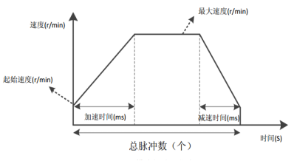
Figure 5.1 Trajectory during normal operation of position mode
Note that in relative positioning mode, the motor's direction is determined by the sign of the total pulse count. Generally, a positive total pulse count indicates forward rotation, while a negative total pulse count indicates reverse rotation. In absolute positioning mode, the motor's initial direction is determined by the sign of the total pulse count, and subsequent directions are also determined by the total pulse count.
If the user-set total pulse count is too low, the motor may need to decelerate before reaching its maximum speed. The speed curve is shown in Figure 6. The solid line shows the actual motor trajectory, and the dashed line shows the trajectory required to accelerate to the set maximum speed. The theoretical total pulse count in the figure is the theoretical minimum total pulse count calculated based on the user-set parameters: starting speed, maximum speed, acceleration time, and deceleration time. If the user-set total pulse count is less than the theoretical minimum total pulse count, the motor will operate according to the solid line in Figure 5.2.
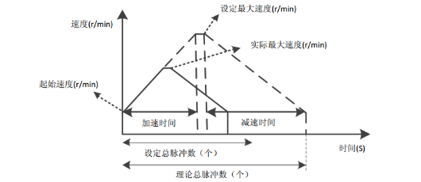
Figure 5.2 Running trajectory when the total number of pulses in position mode is set to be small

5.2 Speed ​​Mode
Speed ​​mode allows the motor to maintain a constant speed at a set speed. Unlike position mode, the user only needs to set the starting speed, maximum speed, acceleration time, and deceleration time. After the motor accelerates to the maximum speed according to the set parameters, it maintains a constant speed. The direction of the motor's rotation is determined by the positive or negative value of the maximum speed. Generally, a positive maximum speed indicates forward rotation, while a negative maximum speed indicates reverse rotation. The acceleration curve for speed mode is shown in Figure 5.3.
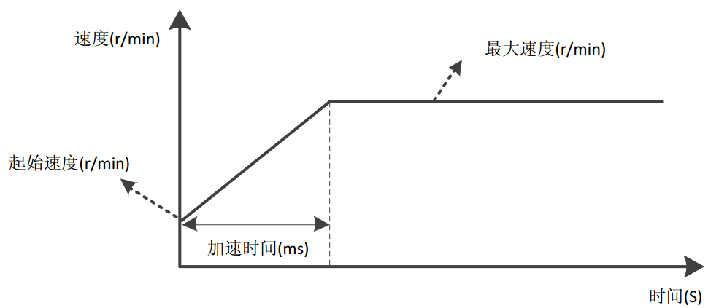
Figure 5.3 Speed ​​mode acceleration curve

5.3 Return to originmodel
IRS42 integrated 485 bus typestepper driverCurrently supported return to zero methods are17-30,33-35, 37-39,These modesLimit is needed、originor Z signal.
Before configuring the homing mode, you must first configure the input port function to origin, positive limit, or negative limit. Modes 17-18 are two limit return modes, modes 19-22 are four origin return modes, modes 23-26 are four origin + positive limit return modes, modes 27-30 are four origin + negative limit return modes, 33-34 are two Z signal return modes, 35 and 37 use the current position as the zero point, and 38-39 are position return modes.
Starting the homing mode,The homing function can be started by sending a 'start command' from the host computer, or by using an external IO signal as a trigger source. However, an inputportThe function of is configured as the "home enable signal" function. Before this, you can use the register0x003B~0x0041 configure the homing mode, homing speed, homing acceleration/deceleration time, and homing compensation valueThe user needs to select the appropriate homing mode according to the actual application.This section briefly introduces severalReturn to origin modePath process.
Icon explanation: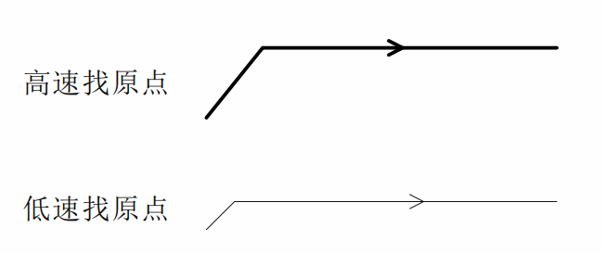
Note:In the following diagrams defining all return-to-zero methods, movement to the right is considered positive movement, and movement to the left is considered negative movement.

5.3.1 Mode 17 (Negative limit return to zero)
The origin stop position of 'Negative limit return to zero' is at the negative limit signal.
The entire action of 'Negative limit return to zero' is divided into two cases, as follows:
Scenario A:After the drive receives the 'home enable signal' command,'Home speed V1'、'Return to origin acceleration and deceleration time'Several parameters start to move, and when they encounter the rising edge of the limit signal,slow downstop.Then it runs in the reverse direction at the 'home speed V2' until it encounters the falling edge of the limit signal, decelerates and stops, and the entire home return action is completed.
Case B:After receiving the 'Home Enable Signal' command, the drive is within the limit and willReturn to origin speed V2', 'Return to originaddThe deceleration time parameter starts to move, and when it encounters the falling edge of the limit signal, decelerate and stop, the whole return to zero action is completed.
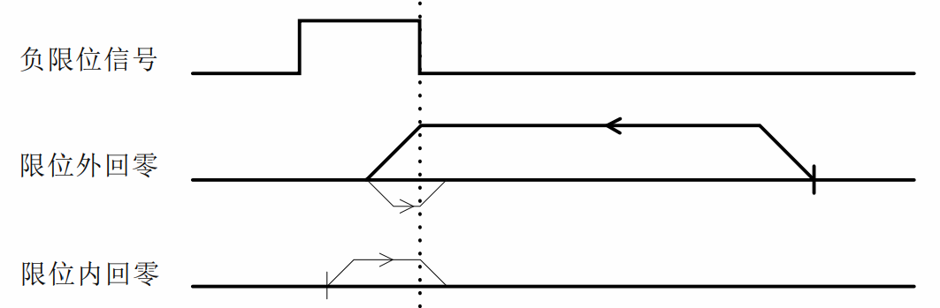

5.3.2 Mode 18 (Positive limit return to zero)
The origin stop position of 'Positive limit return to zero' is at the positive limit signal.
'Positive limit return to zero' is similar to 'Negative limit return to zero', except that the running direction is opposite, so it will not be explained in detail here.
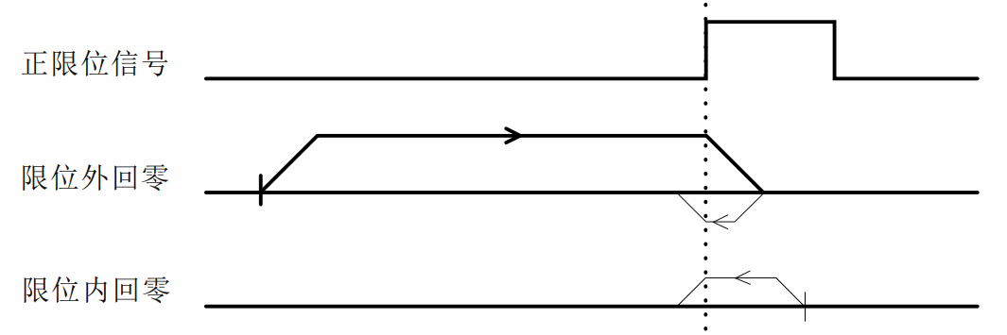

5.3.3 Mode 19 (origin return 1)
The origin stop position of 'Home Return 1' is on the left side of the rising edge of the origin signal in the positive direction.
The whole action of 'origin return 1' is divided into two cases, as follows:
Scenario A:After the drive receives the 'home enable signal' command,'Home speed V1'、'Return to origin acceleration and deceleration time'Several parametersIn the positive directionSports, when encounteringoriginWhen the signal rises,slow downstop.Then it runs in the opposite direction at the 'home return speed V2' until it encounters the falling edge of the home signal, decelerates and stops, and the entire home return action is completed.
Case B:After receiving the 'home enable signal' command, the drive is inorigin signalInside, it willby'Return to origin speed V2', 'Return to originaddDeceleration time'severalparameterIn the opposite directionSports, when encounteringoriginSignal falling edge,slow downstop, the whole return to zero action is completed.
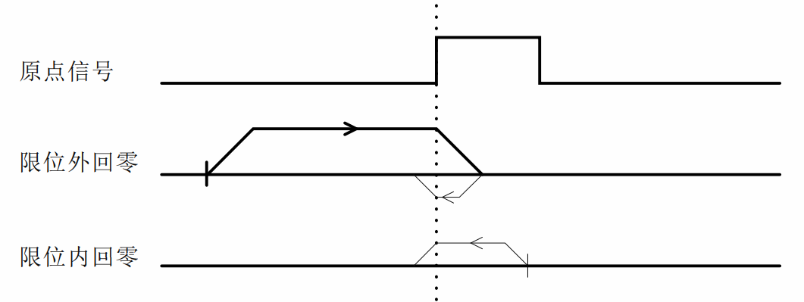

5.3.4 Mode 20 (origin return 2)
The origin stop position of 'Home Return 2' is to the right of the rising edge of the origin signal in the positive direction.
The entire process of 'Home Return 2' is shown in the figure below. Detailed description is omitted here.
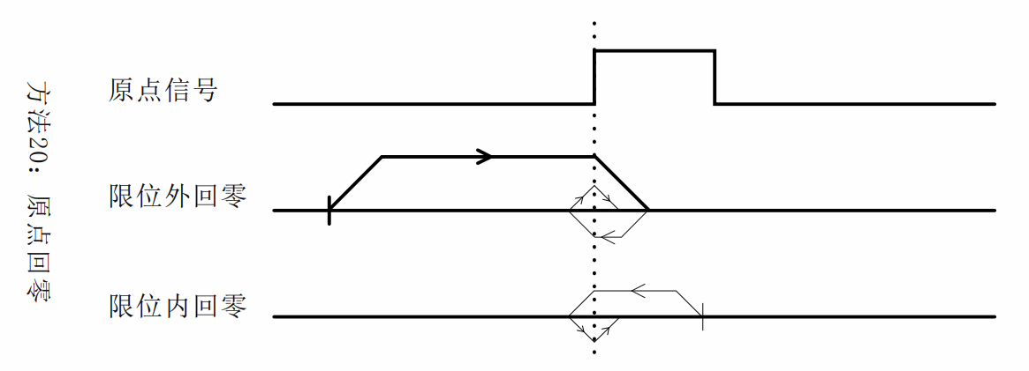

5.3.5 Method 21 (origin return 3)
The origin stop position of 'Home Return 3' is to the right of the rising edge of the origin signal in the reverse direction.
The entire operation of 'Home Return 3' is similar to 'Home Return 1', except that the initial running direction is opposite. Detailed description is not given here.
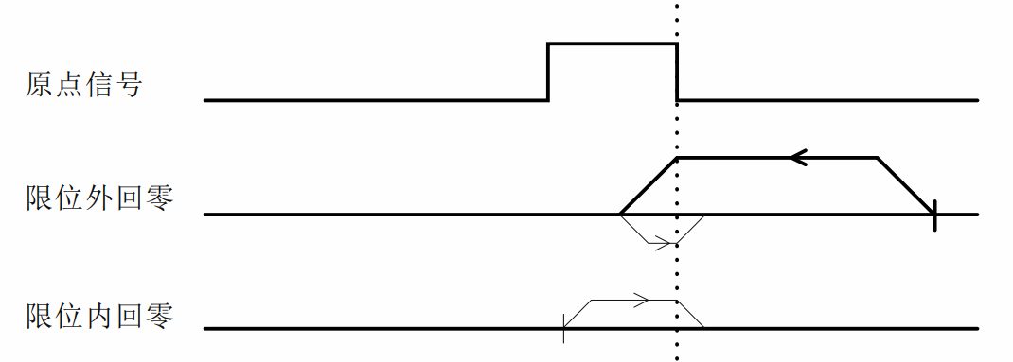

5.3.6 Mode 22 (origin return 4)
The origin stop position of 'Home Return 4' is on the left side of the rising edge of the origin signal in the reverse direction.
The entire operation of 'Home Return 4' is similar to 'Home Return 2', except that the initial running direction is opposite. Detailed description is not given here.
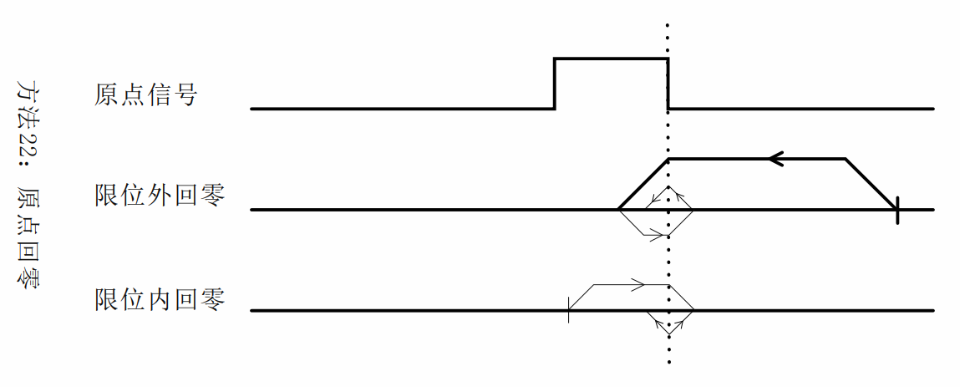

5.3.7 Mode 23 (origin + positive limit return to zero 1)
The origin stop position of 'Origin + Positive Limit Return to Zero 1' is on the left side of the rising edge of the origin signal in the positive direction.
The entire action of 'origin + positive limit return to zero 1' is divided into three cases, as follows:
Scenario A:After the drive receives the 'home enable signal' command,'Home speed V1'、'Return to origin acceleration and deceleration time'Several parametersIn the positive directionSports, when encounteringoriginWhen the signal rises,slow downstop.Then it runs in the opposite direction at the 'home return speed V2' until it encounters the falling edge of the home signal, decelerates and stops, and the entire home return action is completed.
Case B:After the drive receives the 'home enable signal' command,'Home speed V1'、'Return to origin acceleration and deceleration time'Several parametersIn the positive directionSports, when encounteringPositive limitWhen the signal rises,immediatelystop.Then it runs in the opposite direction at the 'home return speed V2' until it encounters the falling edge of the home signal, decelerates and stops, and the entire home return action is completed.
Case C:After receiving the 'home enable signal' command, the drive is inorigin signalInside, it willby'Return to origin speed V2', 'Return to originaddDeceleration time'severalparameterIn the opposite directionSports, when encounteringoriginSignal falling edge,slow downstop, the whole return to zero action is completed.
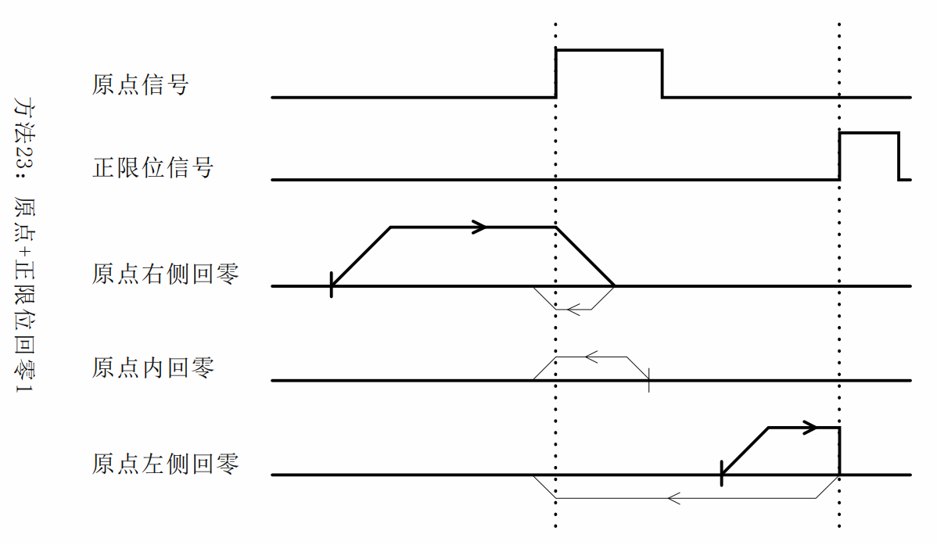

5.3.8 Mode 24 (origin + positive limit return to zero 2)
The origin stop position of 'Origin + Positive Limit Return to Zero 2' is to the right of the rising edge of the origin signal in the positive direction.
The entire operation of 'origin + positive limit return to zero 2' is shown in the figure below. Detailed explanation is omitted here.
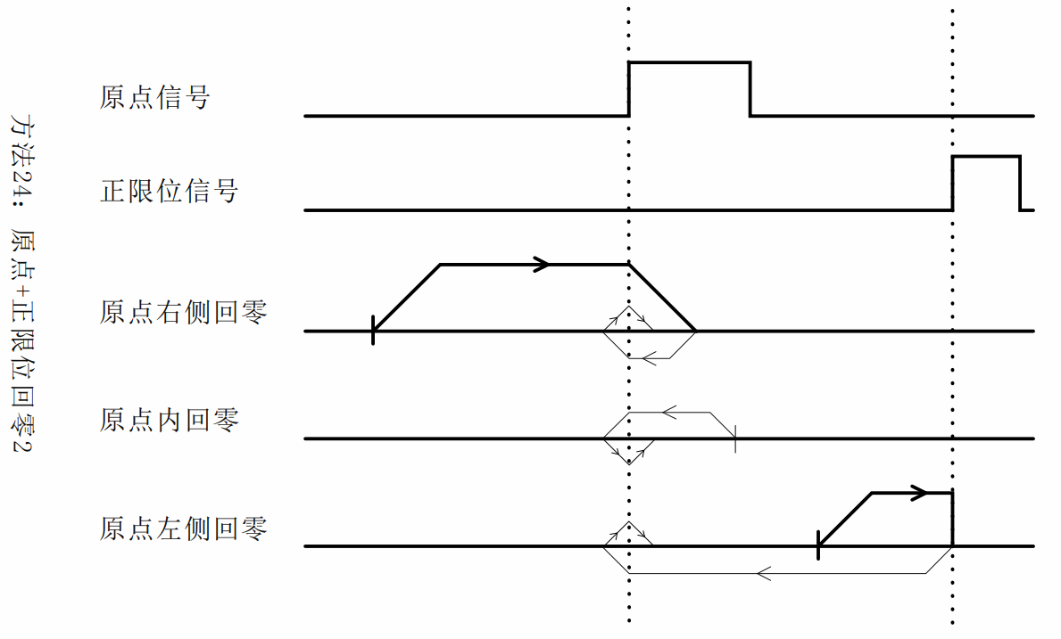

5.3.9 Mode 25 (origin + positive limit return to zero 3)
The origin stop position of 'Origin + Positive Limit Return to Zero 3' is on the left side of the falling edge of the origin signal in the positive direction.
The entire action of 'origin + positive limit return to zero 1' is divided into three cases, as follows:
Scenario A:After the drive receives the 'home enable signal' command,'Home speed V1'、'Return to origin acceleration and deceleration time'Several parametersIn the positive directionSports, when encounteringoriginWhen the signal rises,Keep running.When encountering the falling edge of the origin signal, it decelerates and stops. Then it runs in the reverse direction at the 'home speed V2' until encountering the rising edge of the origin signal, decelerates and stops, and the whole return to zero action is completed.
Case B:After the drive receives the 'home enable signal' command,'Home speed V1'、'Return to origin acceleration and deceleration time'Several parametersIn the positive directionSports, when encounteringPositive limitWhen the signal rises,immediatelystop.Then it runs in the reverse direction at the 'home return speed V2' until it encounters the rising edge of the home signal, decelerates and stops, and the entire home return action is completed.
Case C:After receiving the 'home enable signal' command, the drive is inorigin signalInside, it willby'Return to origin speed V1', 'Return to originaddDeceleration time'severalparameterIn the positive directionSports, when encounteringoriginSignal falling edge,slow downstopThen it runs in the reverse direction at the 'home speed V2' until it encounters the rising edge of the home signal, decelerates and stops, and the entire home return action is completed.
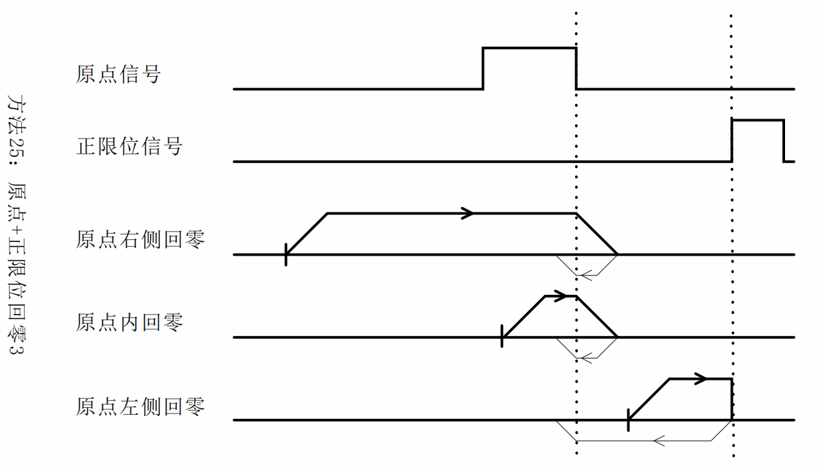

5.3.10 Mode 26 (origin + positive limit return to zero 4)
The origin stop position of 'Origin + Positive Limit Return to Zero 4' is to the right of the falling edge of the origin signal in the positive direction.
The entire operation of 'origin + positive limit return to zero 4' is shown in the figure below. Detailed explanation is omitted here.
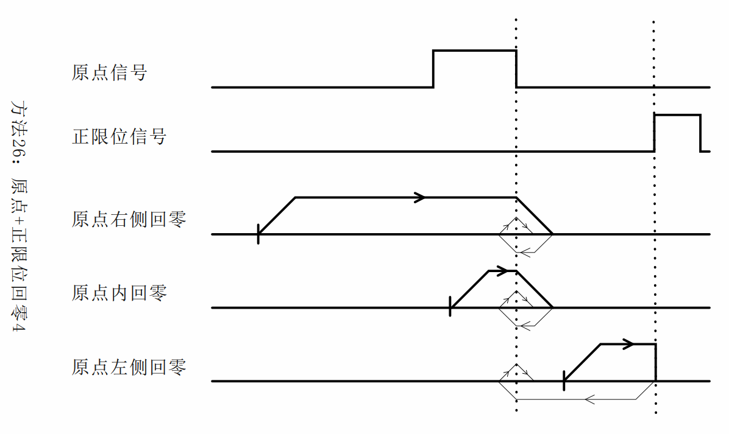

5.3.11 Mode 27 (origin + negative limit return to zero 1)
The origin stop position of 'origin + negative limit return to zero 1' is to the right of the rising edge of the origin signal in the opposite direction.
The entire operation of 'Origin + Negative Limit Return to Zero 1' is similar to 'Origin + Positive Limit Return to Zero 1', except that the initial running direction is opposite. Detailed explanation is not given here.
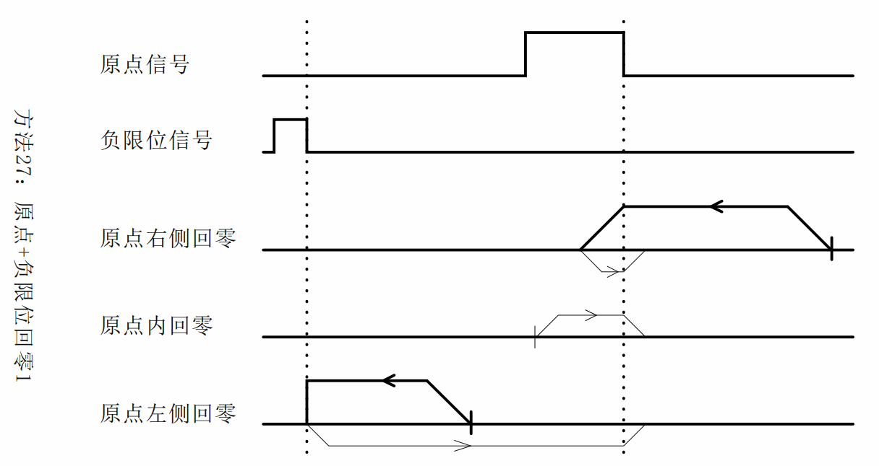

5.3.12 Mode 28 (origin + negative limit return to zero 2)
The origin stop position of 'origin + negative limit return to zero 2' is on the left side of the rising edge of the origin signal in the opposite direction.
The entire operation of 'Origin + Negative Limit Return to Zero 2' is similar to 'Origin + Positive Limit Return to Zero 2', except that the initial running direction is opposite. Detailed explanation is not given here.
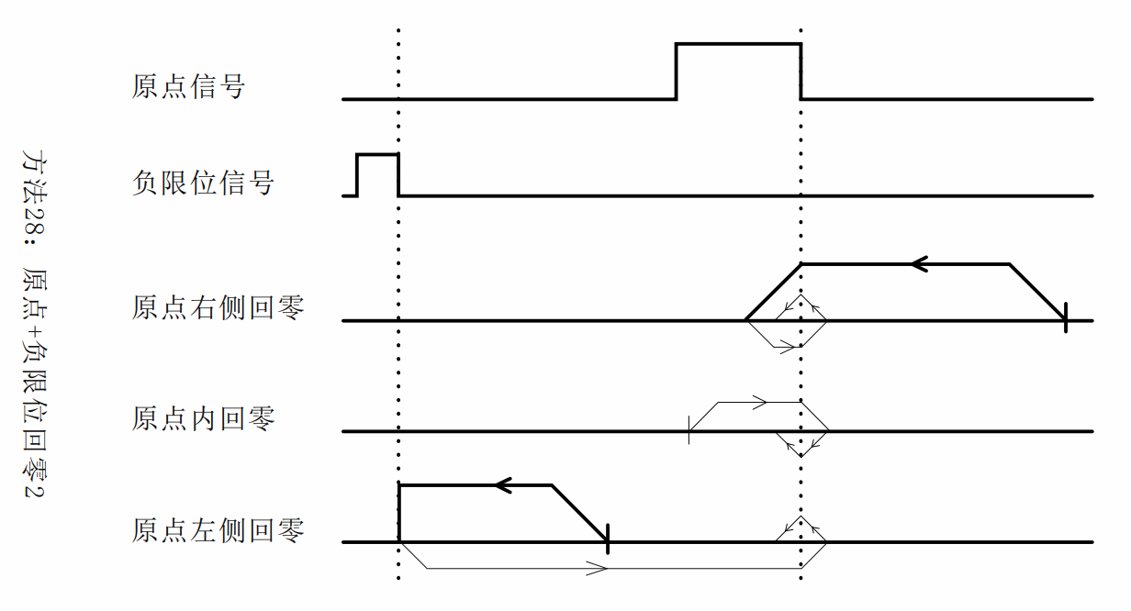

5.3.13 Mode 29 (origin + negative limit return to zero 3)
The origin stop position of 'origin + negative limit return to zero 3' is to the right of the falling edge of the origin signal in the opposite direction.
The entire operation of 'Origin + Negative Limit Return to Zero 3' is similar to 'Origin + Positive Limit Return to Zero 3', except that the initial running direction is opposite. Detailed explanation is not given here.
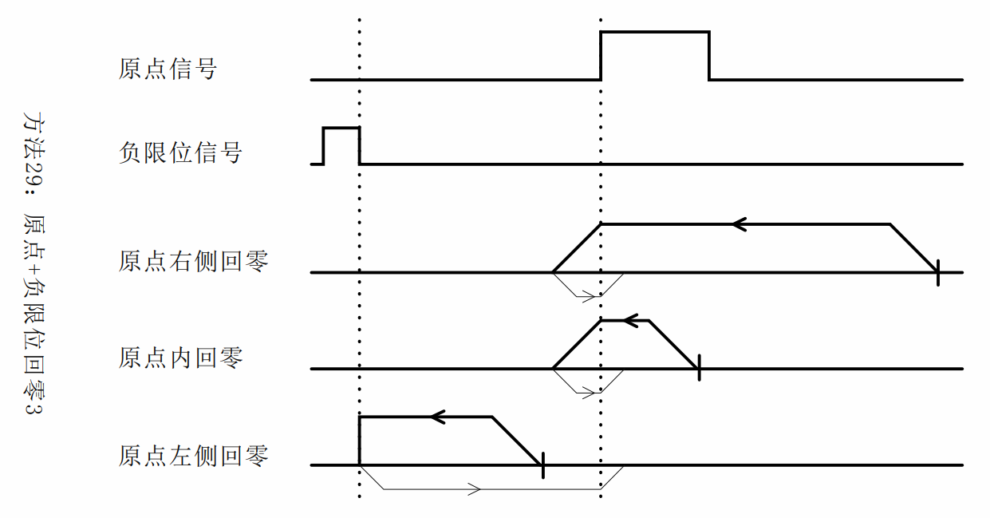

5.3.14 Mode 30 (origin + negative limit return to zero 4)
The origin stop position of 'origin + negative limit return to zero 4' is on the left side of the falling edge of the origin signal in the opposite direction.
The entire operation of 'Origin + Negative Limit Return to Zero 4' is similar to 'Origin + Positive Limit Return to Zero 4', except that the initial running direction is opposite. Detailed explanation is not given here.
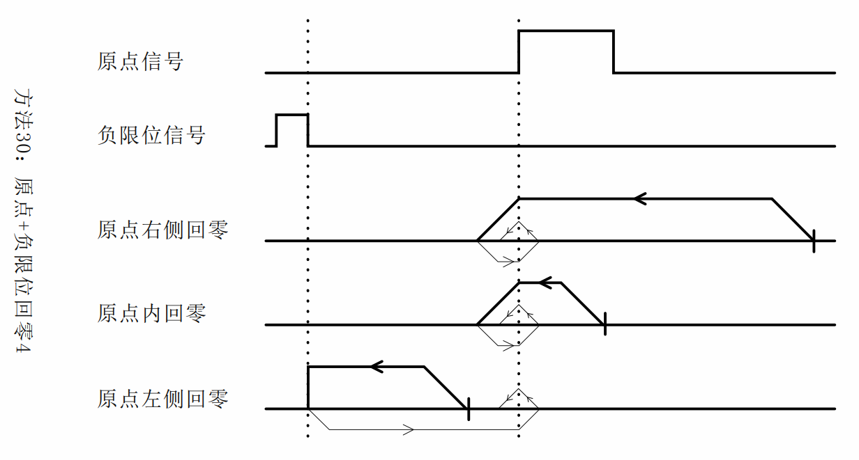

5.3.15 Mode 33 (Z signal return to zero 1)
This zero return method uses the Z signal as the zero return detection signal, which is consistent with the direction of 'negative limit zero return'. The origin stop position is to the right of the Z signal.
The entire process of 'Z signal return to zero 1' is shown in the figure below. Detailed description is omitted here.
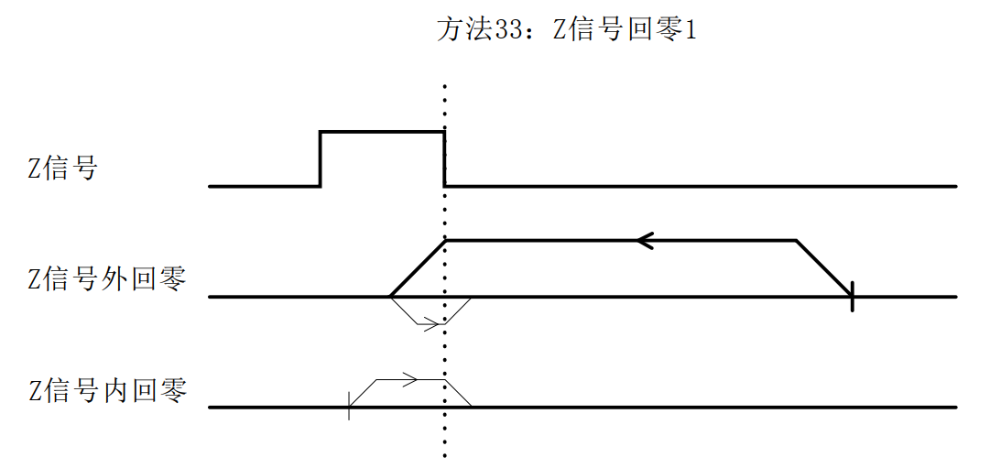

5.3.16 Mode 34 (Z signal returns to zero 2)
This zero return method uses the Z signal as the zero return detection signal, which is consistent with the direction of the 'positive limit zero return'. The origin stop position is on the left side of the Z signal.
The entire process of 'Z signal return to zero 2' is shown in the figure below. Detailed description is omitted here.
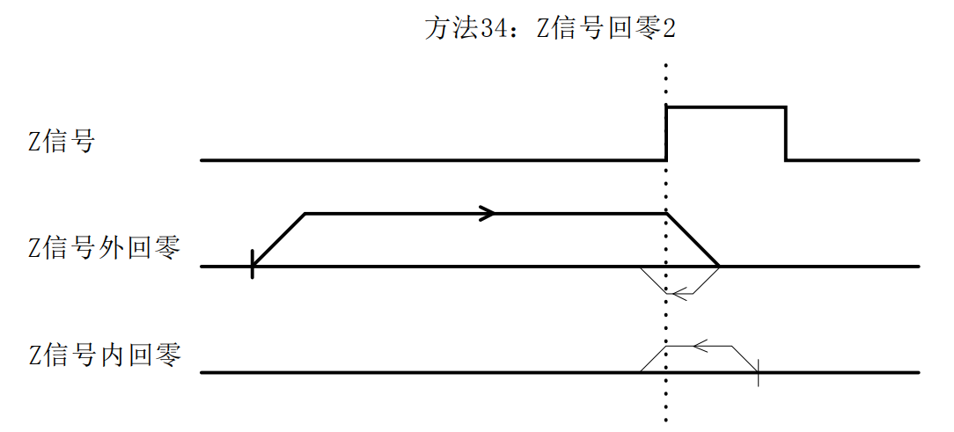

5.3.17 Methods 35 and 37 (the current position is the origin)
This zero return method uses the current point as the origin.

5.3.18 Mode 38 (position return to zero mode 1)
This zero return method is consistent with the negative limit zero return direction. When the operation reaches the set position, it stops immediately and takes this position as the origin.
The position value is set through registers 0x0044 and 0x0045;

5.3.19 Mode 39 (position return to zero mode 2)
This zero return method is consistent with the positive limit zero return direction. When the operation reaches the set position, it stops immediately and takes this position as the origin.
The position value is set through registers 0x0044 and 0x0045;

5.4 Multi-segment mode
The multi-segment mode includes multi-segment position mode and multi-segment speed mode, and the register range involved is 0x0060~0x015F.

5.4.1 Multi-position mode
The multi-segment position mode combines multiple position segments and sets them according to their path IO numbers (PTIN0~PTIN3) and external IO trigger signals (TRIG, you can also set it not to require this trigger signal) Start the motor and complete a series of position actions.
The multi-segment position mode function setting mainly uses two registers (taking path 0 as an example), as shown in the following table:
Register Name | Included Features
Path 0 function setting 1 | - Position/velocity mode;  - Relative/absolute position selection;  - IO in place output signal is prohibited;  - Whether to jump;  - Jump path number;
Path 0 function setting 2 | - Whether homing is enabled;  - Whether to execute the path after returning to the origin;  - Selection of parameters such as the speed of returning to the origin;  - Return to origin method;
By configuring the function registers of the corresponding paths, various position control modes can be achieved, such as IO trigger + path IO mode, IO trigger single cycle mode, IO trigger continuous cycle mode, etc. Users can configure them according to different needs. The following is a brief introduction to the three commonly used modes.

5.4.1.1 IO Trigger + Path IO Mode
The IO trigger + path IO mode means that the execution of each position segment requires the path IO number (PTIN0~PTIN3) and the external IO trigger signal (TRIG) to start the motor. The execution diagram is shown below.
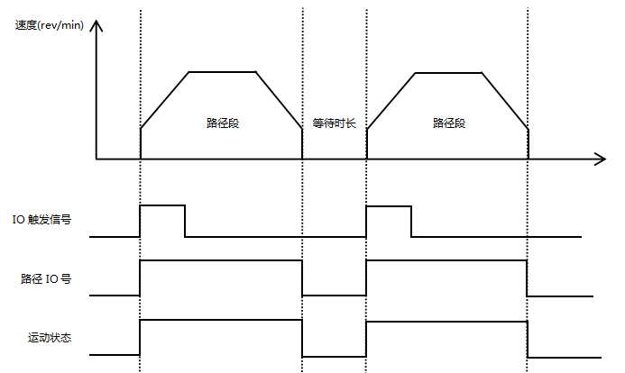
Figure 5.4IO trigger + path IO mode operation diagram
Note: The path jump function cannot be enabled in this mode, and the IO trigger signal for the next path can only be given after the waiting time is over!
If a path needs to return to the origin before executing it, you need to configure the function of the register 'Path Function Setting 2', turn on the return to origin enable bit, select parameters such as the return to origin speed, whether to execute the path after returning to the origin, and the corresponding return to origin method. The execution diagram is shown below.
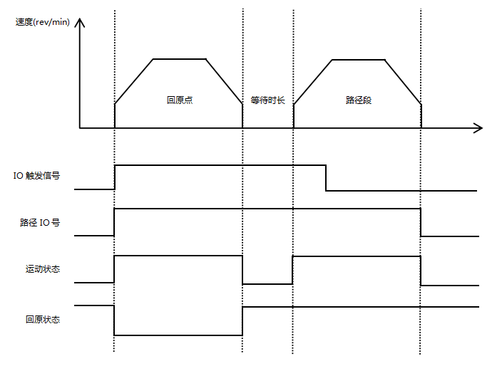
Figure 5.5Schematic diagram of homing + IO triggering + path IO mode operation
Path IO combinations are currently available up to1IO ports,By setting whether the IO trigger function is valid,supportStart 1 stagePosition and combination logic are shown in the following table.
IO port/run path segment | PTIN0 | Path IO  Combined Value | IO triggerFunction(TRIG)efficient | IO triggerFunction(TRIG)invalid
Path segment 0 | 0 | 0 | No such feature | -(invalid)
Path segment 1 | 1 | 1 | No such feature | - (bootable)

5.4.1.2 IO trigger single cycle mode
IO trigger single cycle mode means that the jump function is enabled for each path(IO trigger function is valid)After that, each time the external IO trigger signal (TRIG) starts the motor, a full cycle is executed. To execute a second cycle, the external IO trigger signal (TRIG) must be triggered again. The execution diagram is shown below.
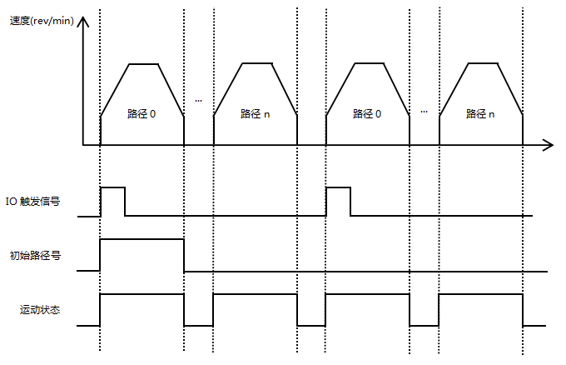
Figure 5.6IO trigger single cycle mode operation diagram
Note: This mode requires the path jump function to be turned on, but the path jump function must be turned off for the last path segment!
If a path needs to return to the origin before executing it, you need to configure the function of the register 'Path Function Setting 2', turn on the return to origin enable bit, select parameters such as the return to origin speed, whether to execute the path after returning to the origin, and the corresponding return to origin method. The execution trajectory of each path is similar to Figure 5.7 and will not be explained here.

5.4.1.3 IO trigger continuous loop mode
IO trigger continuous loop mode means that each path has the jump function enabled(IO trigger function is valid)After that, when the external IO trigger signal (TRIG) starts the motor, it can execute the pre-set position segment cyclically. The execution diagram is shown below.
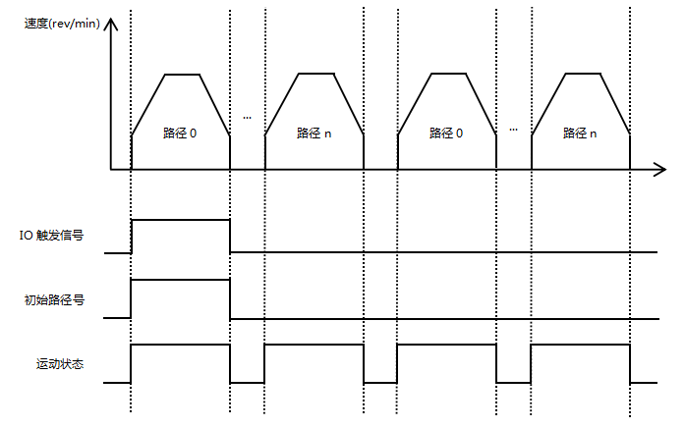
Figure 5.7IO trigger continuous loop mode operation diagram
Note: This mode requires the path jump function to be enabled, and the jump path of the last path segment n must be set to the initial path!
If a path needs to return to the origin before executing it, you need to configure the function of the register 'Path Function Setting 2', turn on the return to origin enable bit, select parameters such as the return to origin speed, whether to execute the path after returning to the origin, and the corresponding return to origin method. The execution trajectory of each path is similar to Figure 5.7 and will not be explained here.

5.4.2 Multi-speed mode
The multi-speed mode combines multiple speed segments and starts the motor according to the path IO number (PTIN0~PTIN3) and the external IO trigger signal (TRIG) to complete a series of speed operations.
The multi-speed mode function setting mainly uses two registers (taking path 0 as an example), as shown in the following table:
Register Name | Included Features
Path 0 function setting 1 | - Position/velocity mode;  - Relative/absolute position selection;  - IO in place output signal is prohibited;  - Whether to jump;  - Jump path number;
Path 0 function setting 2 | (1) Whether homing is enabled;  (2) Whether to execute the path after returning to the origin;  (3) Selection of parameters such as the speed of returning to the origin;  (4) Return to origin method;
By configuring the function register of the corresponding path, the corresponding path can be configured to run in speed mode. Before executing speed mode, you can also perform actions such as returning to the origin. However, please note that the jump function is not supported in multi-speed mode. The execution diagram is shown below.
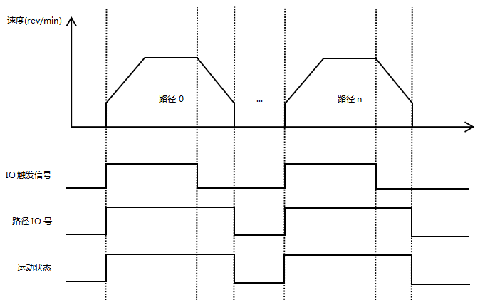
Figure 5.8IO trigger + path IO mode operation diagram
If a path at a certain speed requires returning to the origin first, you need to configure the register 'Path Function Setting 2' function, turn on the return to origin enable bit, select parameters such as the return to origin speed, whether to execute the path after returning to the origin, and the corresponding return to origin method. The execution trajectory of each path is similar to Figure 5.7.
Path IO combinations are currently available up to1IO ports,By setting whether the IO trigger function is valid,supportStart 1 stagePosition and combination logic are shown in the following table.
IO port/run path segment | PTIN0 | Path IO  Combined Value | IO triggerFunction(TRIG)efficient | IO triggerFunction(TRIG)invalid
Path segment 0 | 0 | 0 | No such feature | -(invalid)
Path segment 1 | 1 | 1 | No such feature | - (bootable)

5.5Motion control instructions

5.5.1 Startup Command
Startup CommandThe address is 0x0037, its functionIncluding speed mode trigger, relative position mode trigger, absolute position mode trigger, and homing mode triggerThe function definition of each bit is shown in the following table:
register | Bit15 | Bit14 | Bit13 | Bit12 | Bit11 | Bit10 | Bit9 | Bit8
0x0037  Startup Command | reserve | reserve | reserve | reserve | reserve | reserve | reserve | reserve
0x0037  Startup Command | Bit7 | Bit6 | Bit5 | Bit4 | Bit3 | Bit2 | Bit1 | Bit0
0x0037  Startup Command | JOG-  sports | JOG+  sports | Multi-speed trigger | Multi-segment position trigger | Return to origin  trigger | Absolute position trigger | Relative position trigger | Speed ​​mode trigger
The following is an example of the settings:
Speed ​​mode motion: 01 06 00 37 00 01 F9 C4
Relative position movement: 01 06 00 37 00 02 B9 C5
Absolute position movement: 01 06 00 37 00 04 39 C7

5.5.2 Stop Command
Stop CommandThe address is 0x0038, and its functions includeNormal stop, emergency stop, continuous operation at the set speed, or operation along the planned trajectory until stopping.The motor operates in position modeorIn speed mode, if a normal stop command is received, the motor will decelerate to a stop according to the set deceleration time, and will stop directly if an emergency stop command is received.The setting value range is 0~2.The function definitions of each setting value are shown in the following table:
register | illustrate
0x0038  Stop Command | 0: normal stop;  1: Emergency stop;  2: Run at the set speed or along the planned trajectory until it stops;
The following is an example of the settings:
Normal stop: 01 06 00 38 00 01 C9 C7
Emergency Stop ： 01 06 00 38 00 02 89 C6
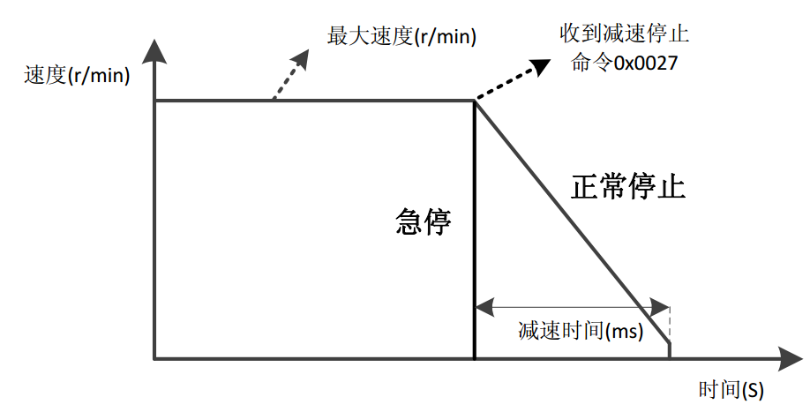
Figure 5.9 Normal stop and emergency stop

Alarm indication

6.1 Alarm fault codes
IRS42 integrated 485 bus open-loop stepper driverThere are multiple alarm messages. When the drive alarms, the fault codes and treatment measures are shown in Table 6.1. For details, please refer to the relevant content of Section 4.2.13 Fault Code Parameter Group.
Table 6.1 Fault codes and solutions
Fault Code | Fault subcode | Fault information | indicator light | Treatment measures
0x01 | 0x10;(reserve) | Overcurrent | Flash | - Check whether the motor wires are connected incorrectly;  - Check whether there is contact between two adjacent wires;  - After troubleshooting, power on again for testing;
0x02 | 0x20: Overvoltage alarm;  0x21: Undervoltage alarm; | Overvoltage and undervoltage | Flash | Check the power supply
0x03 | 0x30: Positive hard limit overtravel;  0x31: Reverse hard limit overtravel;  0x32: Forward soft limit overtravel;  0x33: Reverse soft limit overtravel; | Hard limit/soft limit overtravel | none | Move in the opposite direction;
0x04 | 0x41: read error;  0x42: write error; | EEPROM  Read and write errors | none | Resettable
0x05 | 0x51: CRC check error;  0x52:Function codemistake;  0x53:Reading illegal dataWrong address;  0x54:Writing dataaddressOut of range;  0x55: ReadregisterNumber overflow (up to 16 at a time)register);  0x56: Function code illegal read and write error;  0x57:In registerWriteData limit exceeded; | MODBUS  Communication Error | none | Resettable
0x06 | 0x60: Both A and B phases are missing alarm;  0x61: Phase A is missing;  0x62: Phase B is missing; | Phase loss alarm | Flash | - Check whether the motor wiring is loose or connected incorrectly;  - After troubleshooting, power on again for testing;
0x07 | 0x70: Normal out-of-tolerance alarm;(reserve)  0x71: Overvoltage causes an out-of-tolerance alarm;(reserve)  0x72: Undervoltage causes out-of-tolerance alarm;(reserve) | Out-of-tolerance alarm | Flash | - Check whether the motor wiring is correct;  - Check whether the current setting is sufficient;  - Check whether the power supply is sufficient;  - The alarm can be cleared by enabling the signal;
0x08 | 0x80: Return to origin timeout alarm; | Return to origin  time outCall the police | Flash | - Check whether the limit is damaged;  - Check whether the limit wiring is loose;  - This alarm can be cleared through the host computer or external IO input function;
0x09 | 0x90:Restore factory settings;  0x91:Save the status parameter group;  0x92: Save the common parameter group;  0x93: Save the common open-loop parameter group;  0x94: Save the closed-loop common parameter group;  0x95: Save basic control parameter group;  0x96: Save the back-to-origin parameter group;  0x97: Save input and output parameter group;  0x98: Save multi-segment mode parameter group;  0x99: save the performance parameter group;  0x9A: Save the brake parameter group;  0x9B: Save fault code parameter group;  0x9C: Save user parameter group;  0x9D~0x9E: Reserved;  0x9F: Save all parameter groups; | Factory Reset/  Save Parameters | Flash | (1) Wait until the indicator light stops flashing and returns to normal display state before proceeding to the next step;
0x0A | 0xA0:Vmax>Vmin; | Alarm when speed parameter setting is unreasonable | none | Check whether the maximum speed value is less than the minimum speed value;

6.2 Indicator LightsFlash
IRS42 integrated 485 bus open-loop stepper driverThere is a green LED and a red LED. One can be used as a power indicator, and the other can be used as a fault indicator, a DIP switch status indicator, or a parameter save or restore indicator. The specific relationship is shown in Table 6.2 below:
When the driver is powered on, the LED is always on, and when the driver is powered off, the LED is off.
When the DIP switch is turned, the green LED will flash twice quickly. This is normal and indicates that the DIP state switch is valid.
When a fault occurs in the drive, the red and green lights flash alternately, with different flashing patterns indicating different fault information. When the fault is corrected by the user, the green LED remains on and the red LED goes out.
When saving/restoring parameters, the red and green lights flash alternately. When saving/restoring parameters is completed, the green LED is always on and the red LED is off.
Table 6.2 LED status indication
Number of LED flashes |  | Phenomenon | illustrate
Green LED | Red LED | After the green light flashes, the red light flashes
0 | - | Green light is always on, red light is off | Driver Enable
1 | - | Green light flashes, red light off | The driver is enabled and receives a pulse or start command
2 | 1 |  | The driver is not enabled and receives a pulse or start command
1 | 4 |  | Overpressure alarm
2 | 4 |  | Undervoltage alarm
1 | 5 |  | Overcurrent alarm (reserved)
1 | 6 |  | AB phase loss alarm
2 | 6 |  | Only A phase loss alarm
3 | 6 |  | Only B phase loss alarm
1 | 8 |  | Timeout alarm in homing mode
1 | 2 |  | Restoring parameters
2 | 2 |  | Saving parameters in progress

Warranty and after-sales

7.1 Warranty

7.1.1 Free warranty
Our company solemnly promises that if any of our products are damaged during use due to the product itself, we will provideOne yearFree repair service. The shipping cost of the product shall be borne by both parties in half.

7.1.2 Warranty Exclusion
- The driver is damaged due to the customer's own wiring errors;
- The driver is damaged due to exceeding the rated working voltage;
- The DC power supply driver is connected to the AC power supply, causing damage to the driver;
- The driver is damaged due to the customer's on-site environment being extremely harsh, such as humidity, extreme cold, extreme heat, etc., without informing our company in advance;
- The customer has dismantled the drive casing without authorization or the serial number label has been torn off;
- 15 days after the customer confirms receipt, the casing is obviously damaged or impacted, resulting in damage to the drive;
- Force majeure natural disasters, such as fire, earthquake, tsunami, typhoon, etc.;
In the above cases, our company will charge a certain amount of repair cost after evaluating the interests of all parties. In other cases, the repair will be free of charge forever.

7.2 Exchange

7.2.1 Product Replacement for Faulty Products
For any faults that occur in new products, our company provides a three-month free replacement service.
Once our technical support staff confirms that the problem is with the product itself, they will ship the product back to us to avoid wasting time and postage. Customers must first return the faulty product by courier or logistics. Upon receipt, we will promptly ship a replacement product to the customer.
Notice:All our products undergo rigorous testing and aging before leaving the warehouse, so it is extremely rare for new products to malfunction. Please be sure to read the instructions carefully or consult our technical support staff when operating, or our technical support staff will assist customers remotely with operation.
- Please note the following points when exchanging goods:
- Please ensure that the packaging is complete when sending it back to avoid damage during transportation;
- Please ensure that the included accessories are complete when exchanging;
- Each driver should be packaged independently in its original outer box to avoid secondary damage to the product during transportation;
- If the driver is returned and it is confirmed that the fault is not due to product failure, but rather due to the customer's negligence, who mistakenly believed that the driver was faulty, our company will not bear the shipping costs (customer negligence includes: incorrect wiring resulting in damage to the driver, poor wiring resulting in the driver being mistakenly believed to be damaged, operating errors resulting in the driver not being able to function properly, etc.).

7.2.2 Exchange for non-product failure
If you are dissatisfied with the appearance or functionality of the product you received and would like to exchange it for a superior driver, you can request a replacement within one week of receiving the product. After verification, we will return the product and, upon confirmation that the returned product is undamaged, has all accessories, and is well packaged, we will replace it with another product. If there is a price difference between the replacement product and the replacement product, the customer will pay the difference.
Note: The replaced product will no longer be eligible for the non-product fault replacement service. The round-trip shipping costs and other expenses incurred by the non-product fault replacement service are borne by the customer!

7.3 Returns
Our company provides a 7-day return service for products with quality problems. If you find any quality problems with the product itself within 7 days of receiving the product (based on the actual date of receipt by the customer), please communicate with our salesperson or technical support personnel in a timely manner. After our technical support personnel confirms that it is a quality problem with the company's product itself, the customer can send the original complete product and its inner and outer packaging, accessories and shipping order back to our company by express delivery or logistics.
If the customer still insists on returning the goods after our company has checked and confirmed that they are correct, the round-trip shipping costs and all other expenses incurred shall be borne by the customer.
- Please note the following points when returning products:
(1) Please contact the relevant department of our company before making a refund;
(2) The product must be in new condition and intact packaging. Please send it back to our company by express or logistics;
(3) We will not accept any complaints caused by customers, such as product appearance damage, incomplete accessories, etc.

7.4 After-sales Service
If you need after-sales service support when using this product, please contact our company as soon as possible.
National free service hotline: 0755-23206995;
Technical specialist service hotline: 18576758897 (Mr. Xie), 17666115681 (Mr. Tuo);
Service hours: Monday to Friday 8:30-17:30 (except national holidays).

Version Revision History
Version number | illustrate | Modification deadlinetime | Preparer/Reviewer
V1.0.0 | Initial use version; | 2021.10.25 | TCJ/XH
V1.0.1 | (1) Modify the baud rate corresponding to turning SW3 to ON in section 3.2.2 Communication Baud Rate Setting to 115200; | 2021.12.13 | TCJ/XH
V1.0.2 | (1) Optimize the description of 0x000B and 0x000C;  (2) Add registers 0x0187 and 0x0188;  (3) Added return to zero mode 33-34, -3, -4, -5, -6; | 2021.12.24 | TCJ/XH
V1.0.3 | (1) Overall optimization and update of document content; | 2022.07.11 | TCJ/XH
V1.0.4 | (1) Section 3.5.1 adds wiring diagrams for NPN and PNP sensors;  (2) Change the setting range and default value of registers 0x0030, 0x003C, and 0x003D;  (3) Added register 0x018F function;  (4) Added register 0x01A0 function in Section 4.2.9;  (5) Modify the flashing pattern of the alarm light in Section 6.2; | 2022.11.3 | TCJ/XH
V1.0.5 | - Optimized the function of changing the input signal in chapter 3.5;  - Optimized and modified the definition, function and other information of registers in Chapter 4.2;  - Optimized and modified the descriptive content of Chapter 4.5 and added a table;  - Chapter 5.3 adds the zero return mode;  - Section 5.4.1 enriched the startup commands;  - Chapter 6.1 enriched the alarm codes; | 2023.12.7 | TCJ/XH
V1.0.6 | (1) Modify the functions related to input and output ports; | 2024.4.9 | TCJ/XH

